- Baroda BNP Paribas Midcap Fund:( 2.5k, 8Y ) : didn't find data.
- Quant Mid Cap: ( 8k ), after corono its performan increased beating index in 7y , handsomel, in 5y last to year touching only last 2 y ar enot good .omg gave +10% in 5y :shock. but in 10y, halat got bit tight.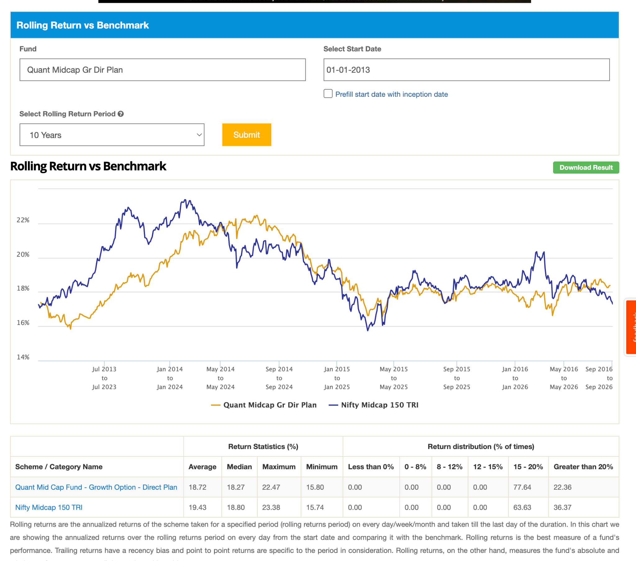 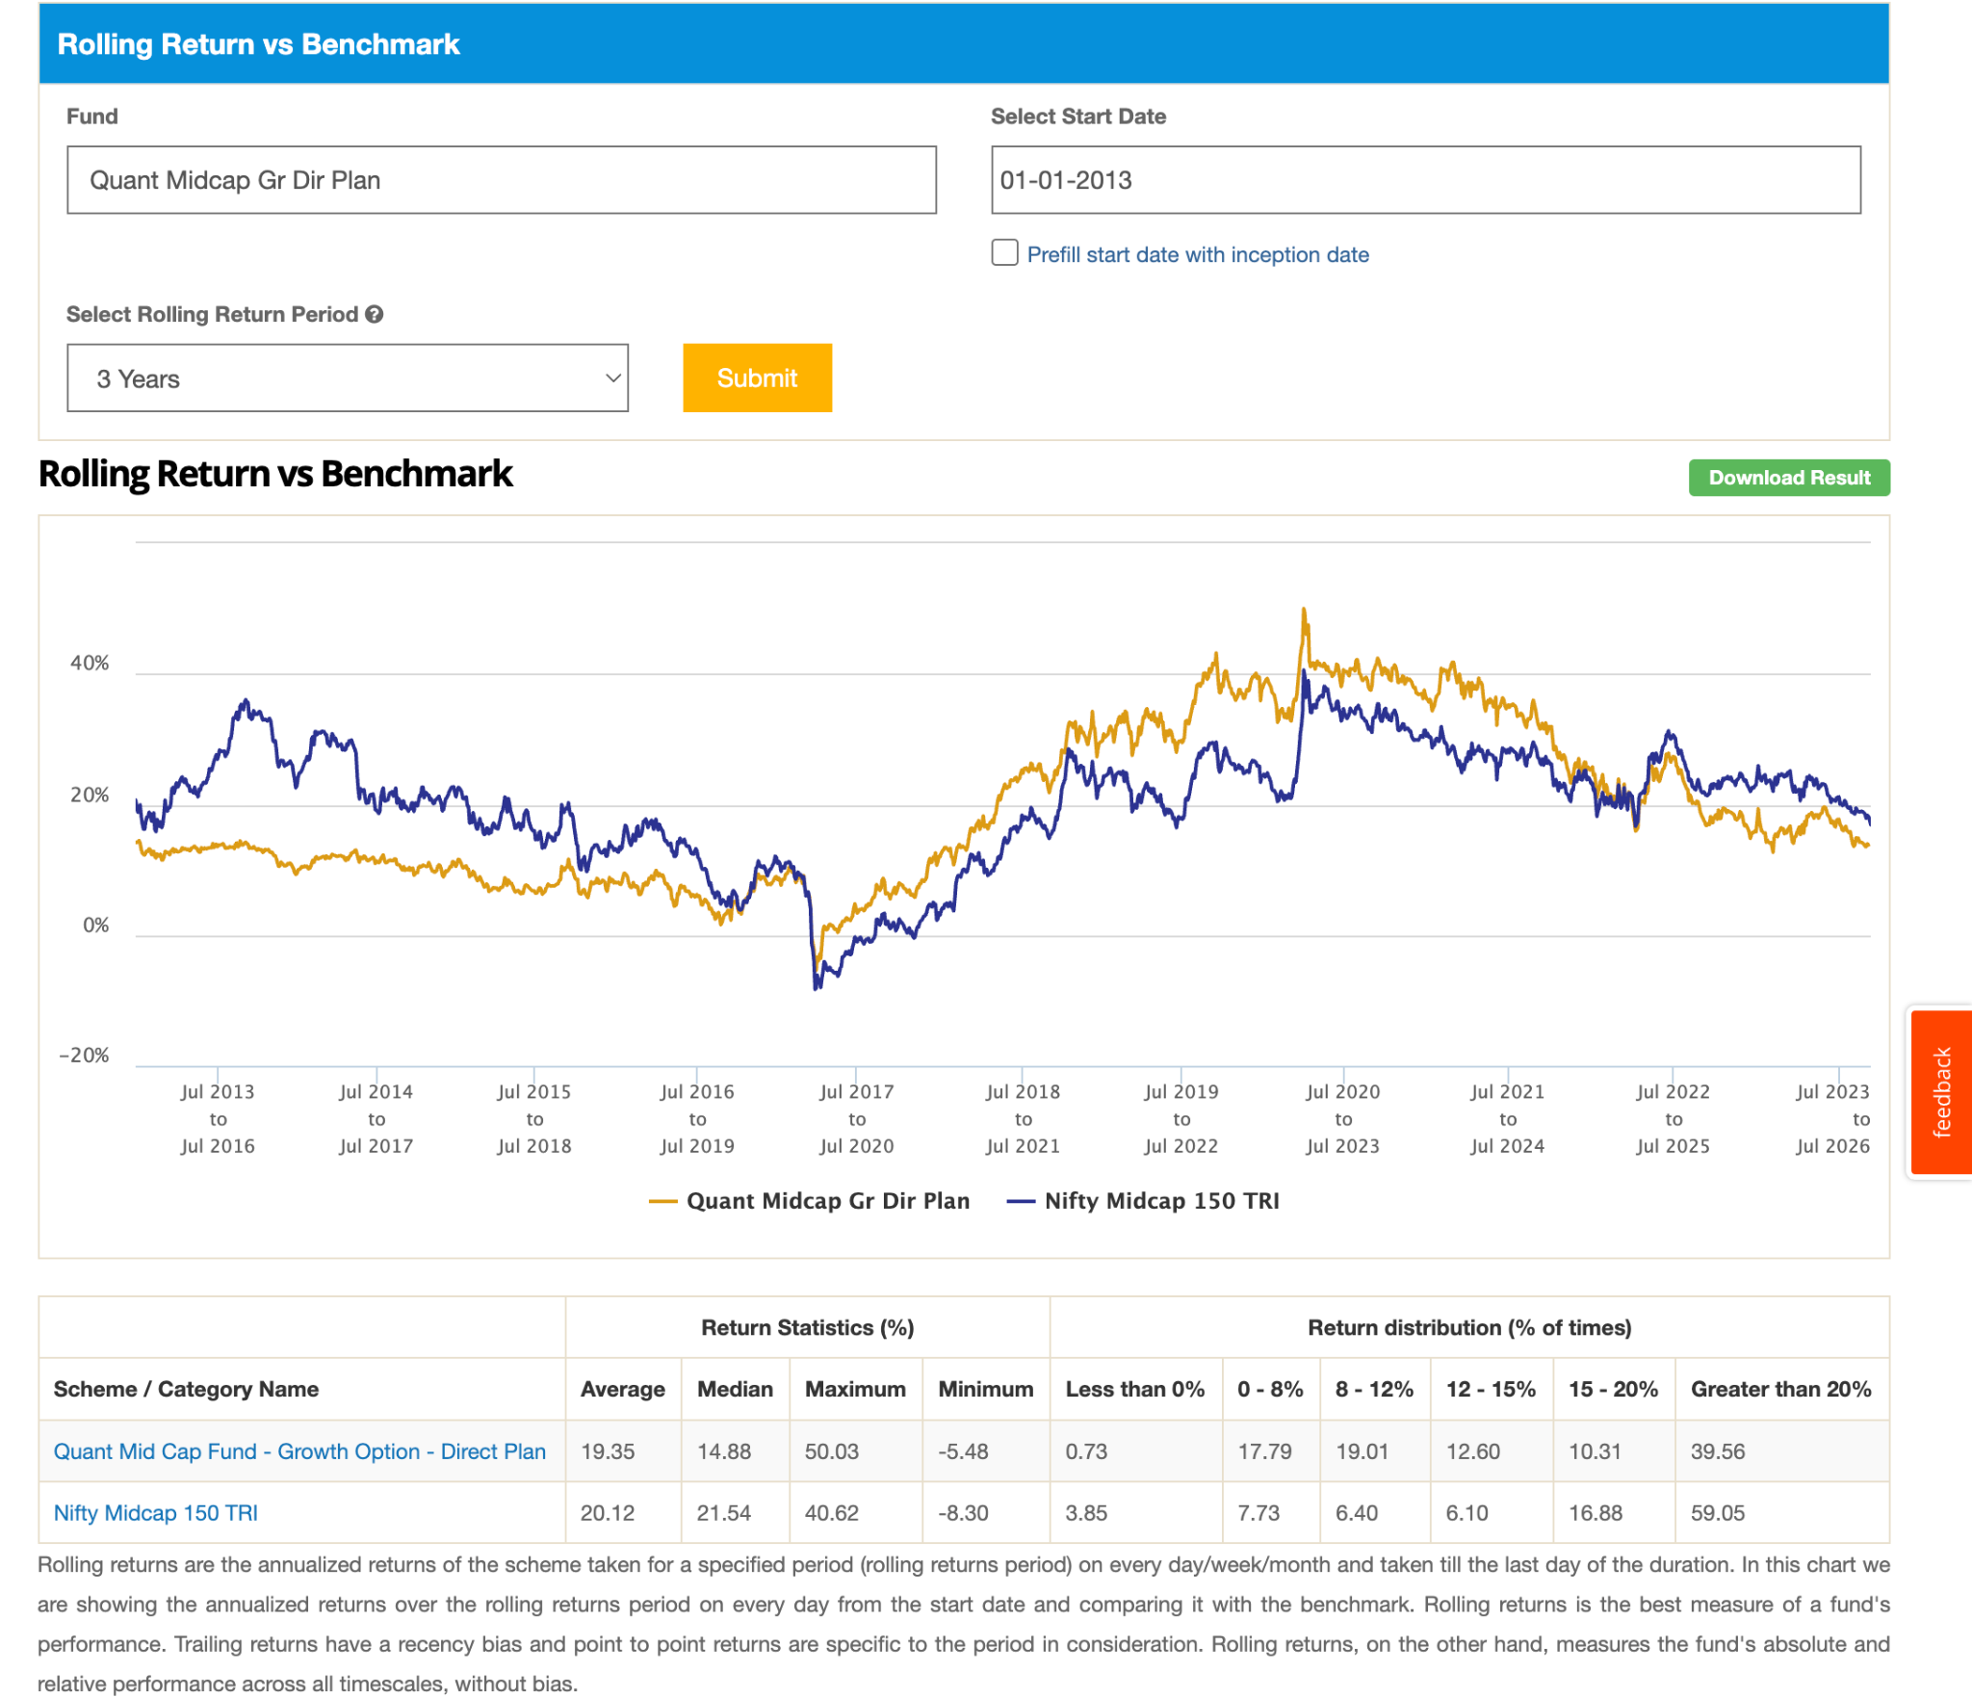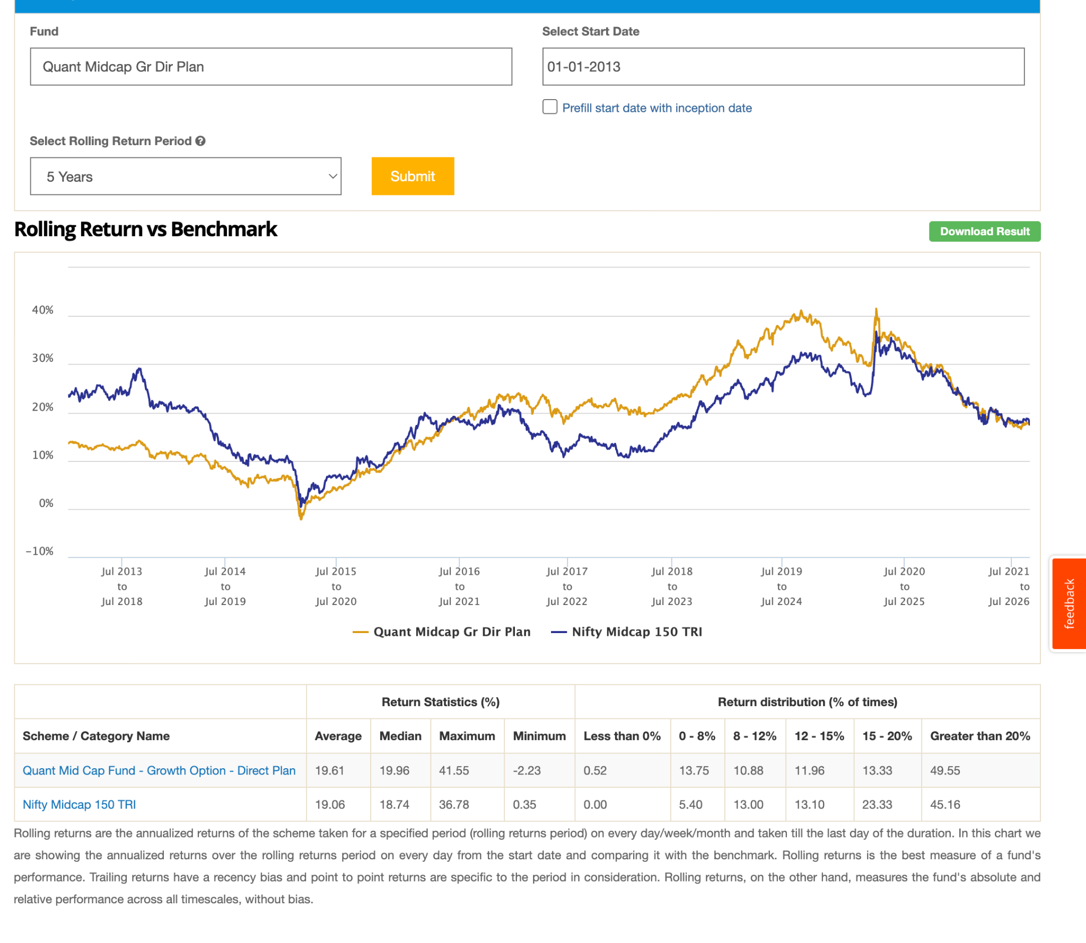y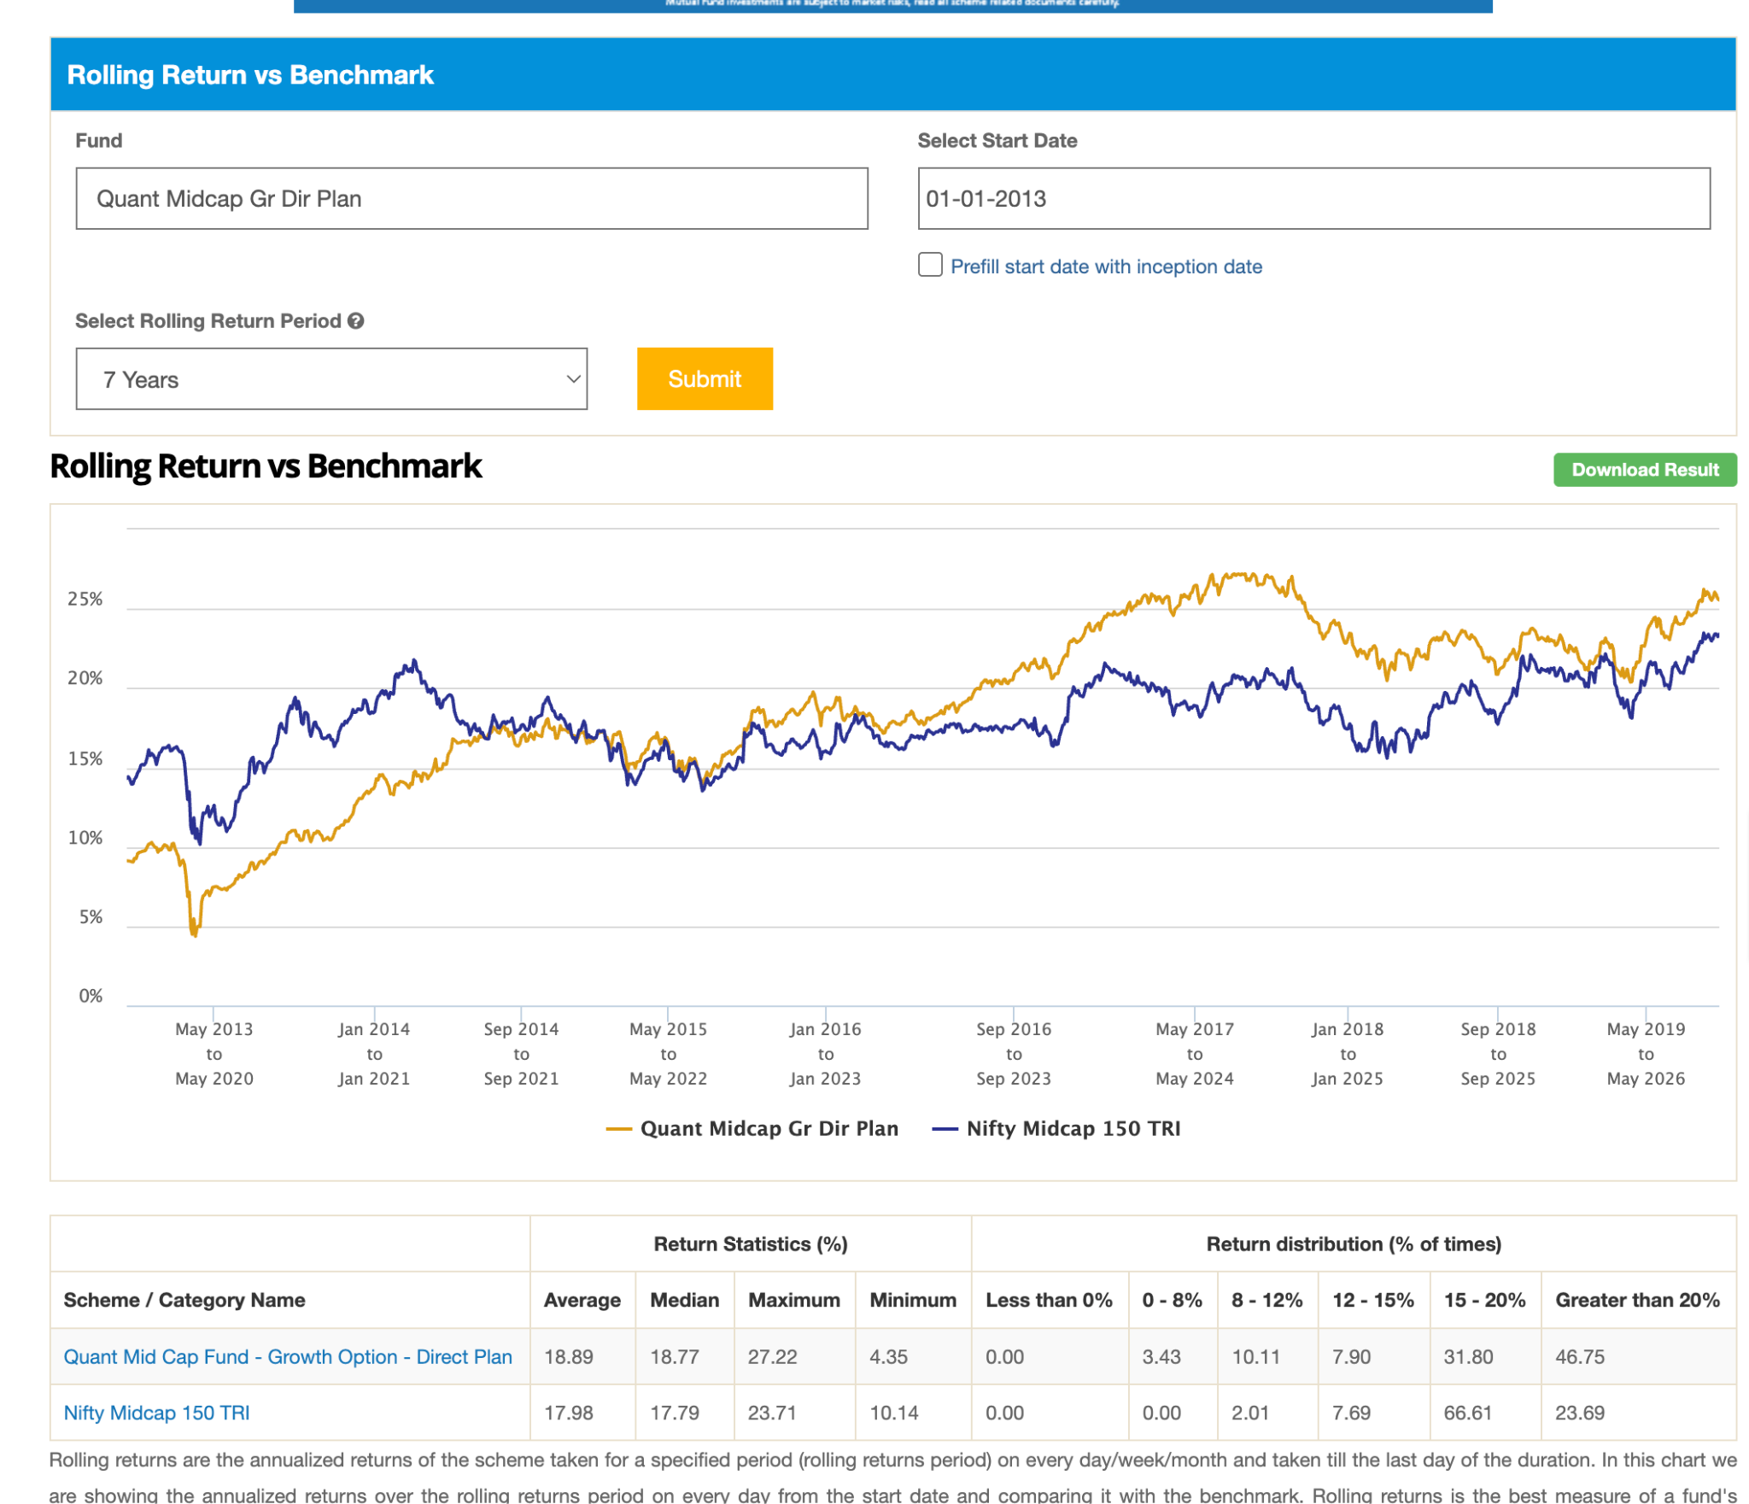
- ITI mid cap: ( 1.5k, 5y ), not able to beat in 5 year , able to beat in 2,3 ( > 50 ) 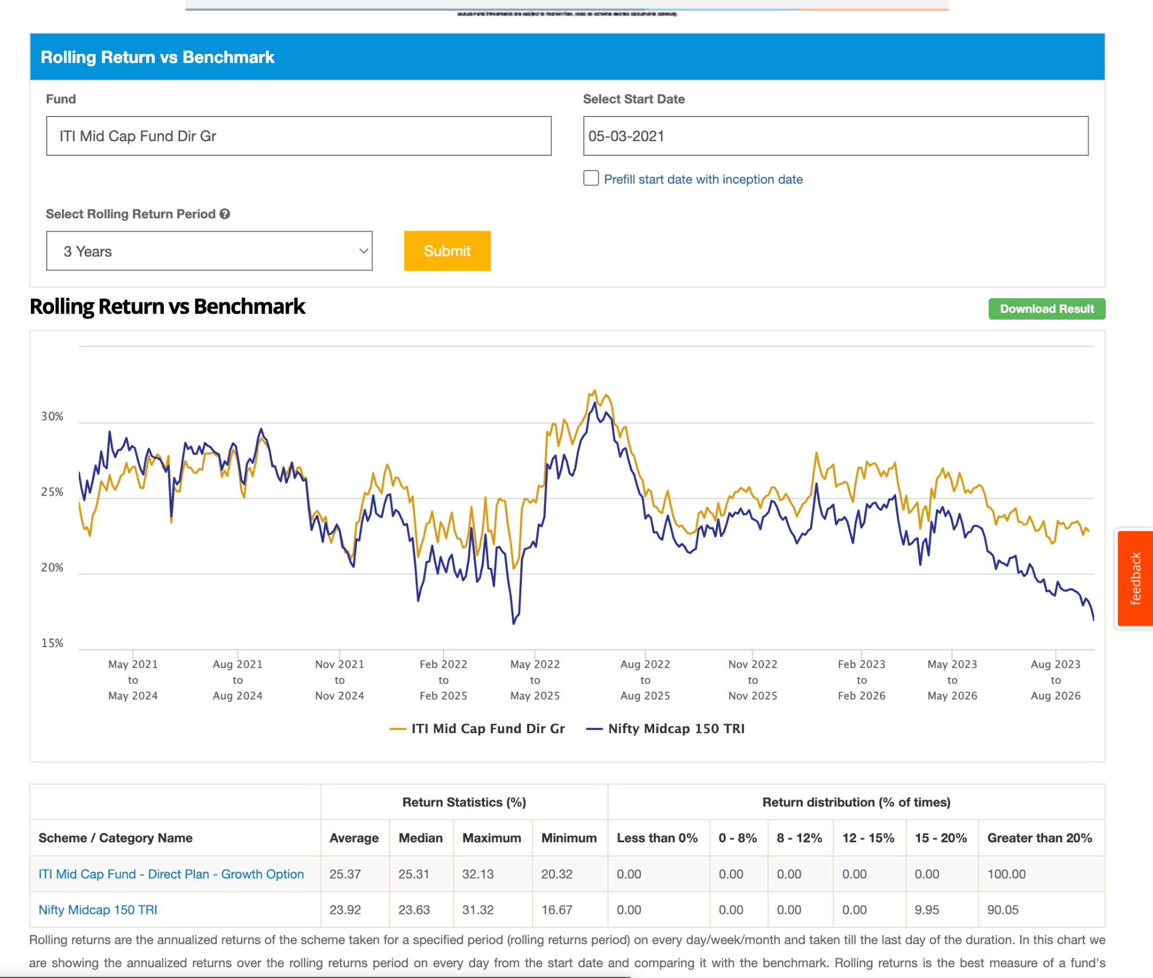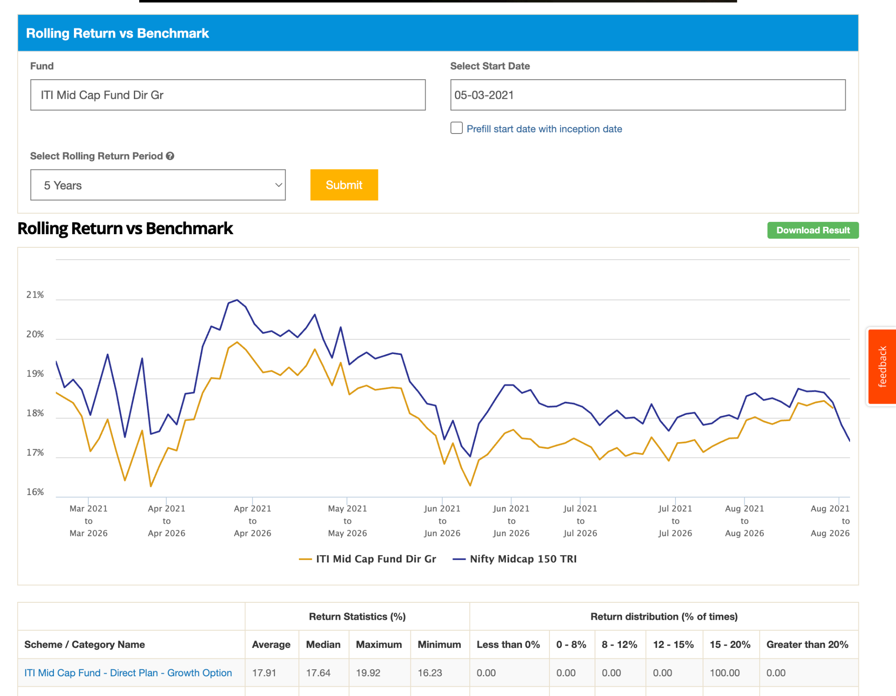
- sundaram mid cap: ( 14.5k ): in 10y always failed to beat even touch., also not in 7y, 5y also barely touching , moved to worst. gave in last 3 year good the reason why has good rating on VR groww, 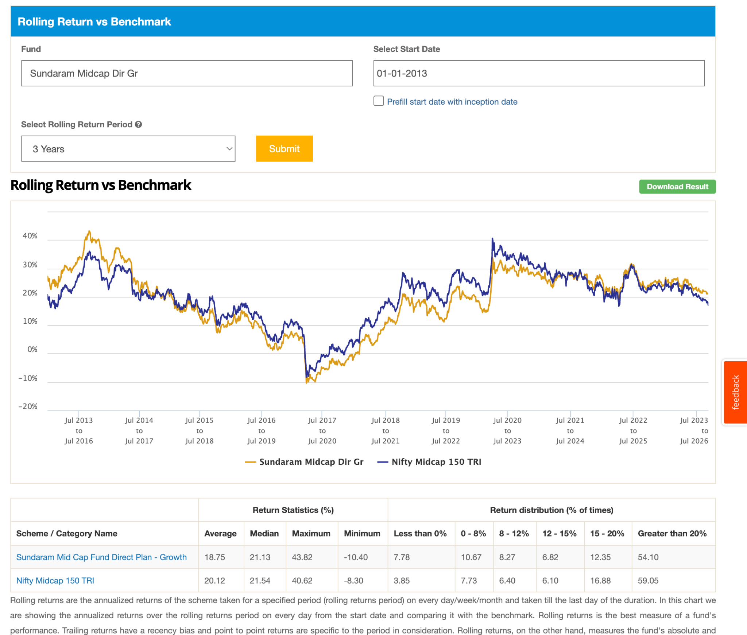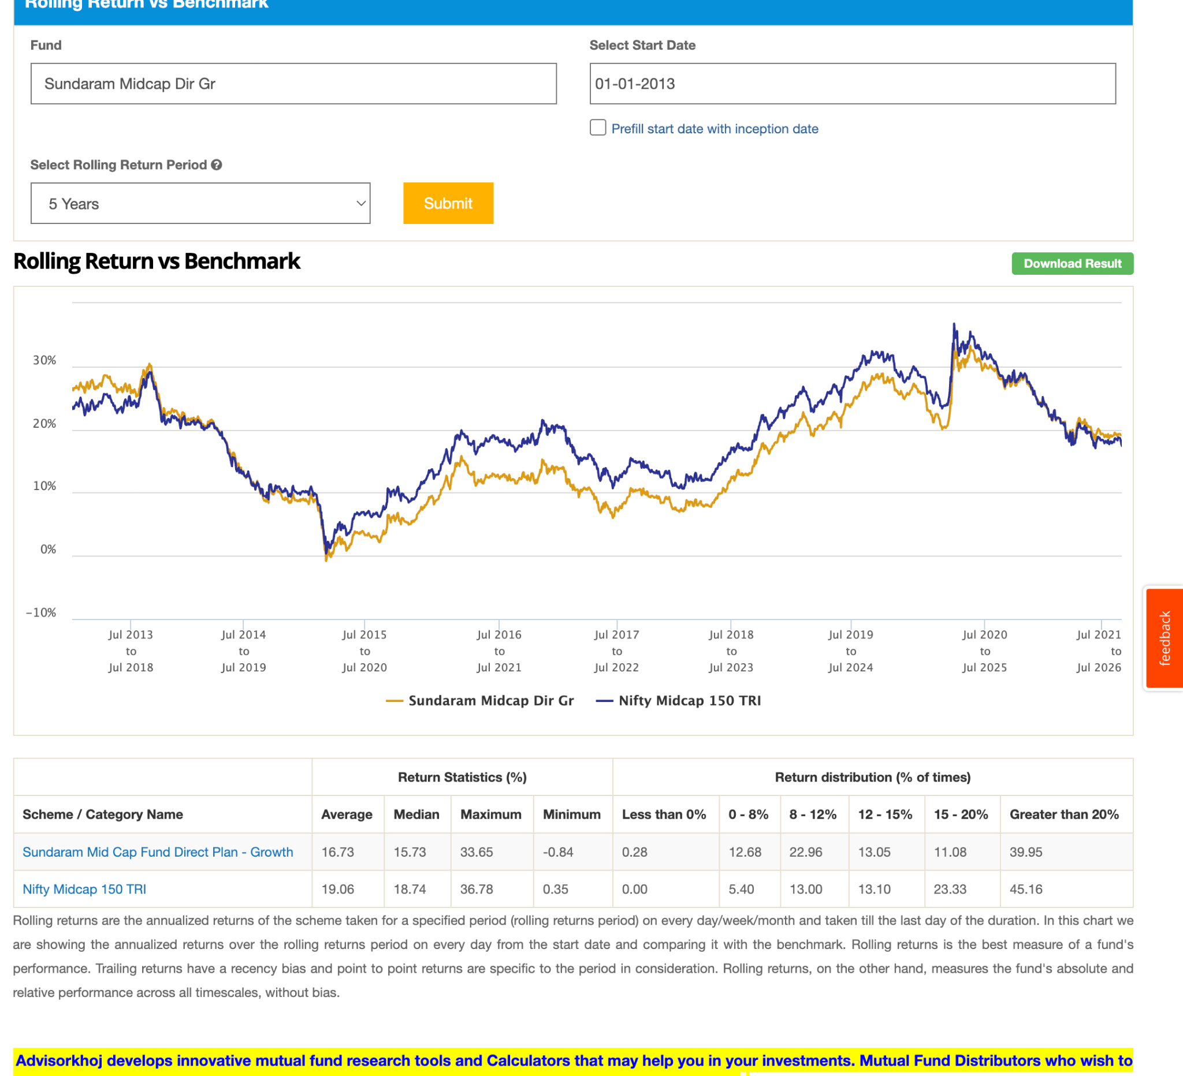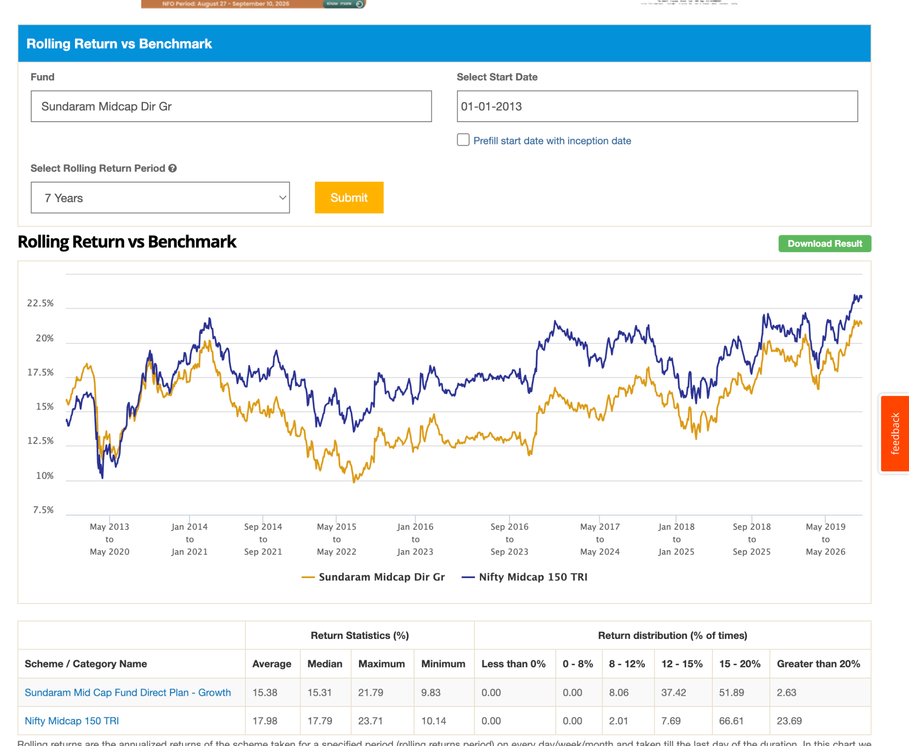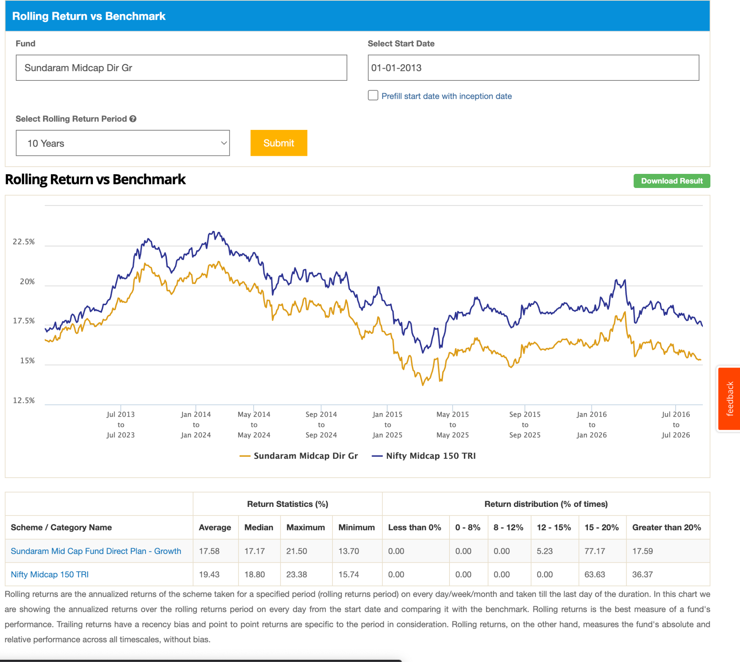
- hsbc mid cap ( 15.5k ): in 5 year not beating index after corona, but like now in 2026 can see able to beat. in 7y after corno no beat now touchin again to index ( mean gaining again ) . in 10 also same pattern seems like took good time to have correct of cornoa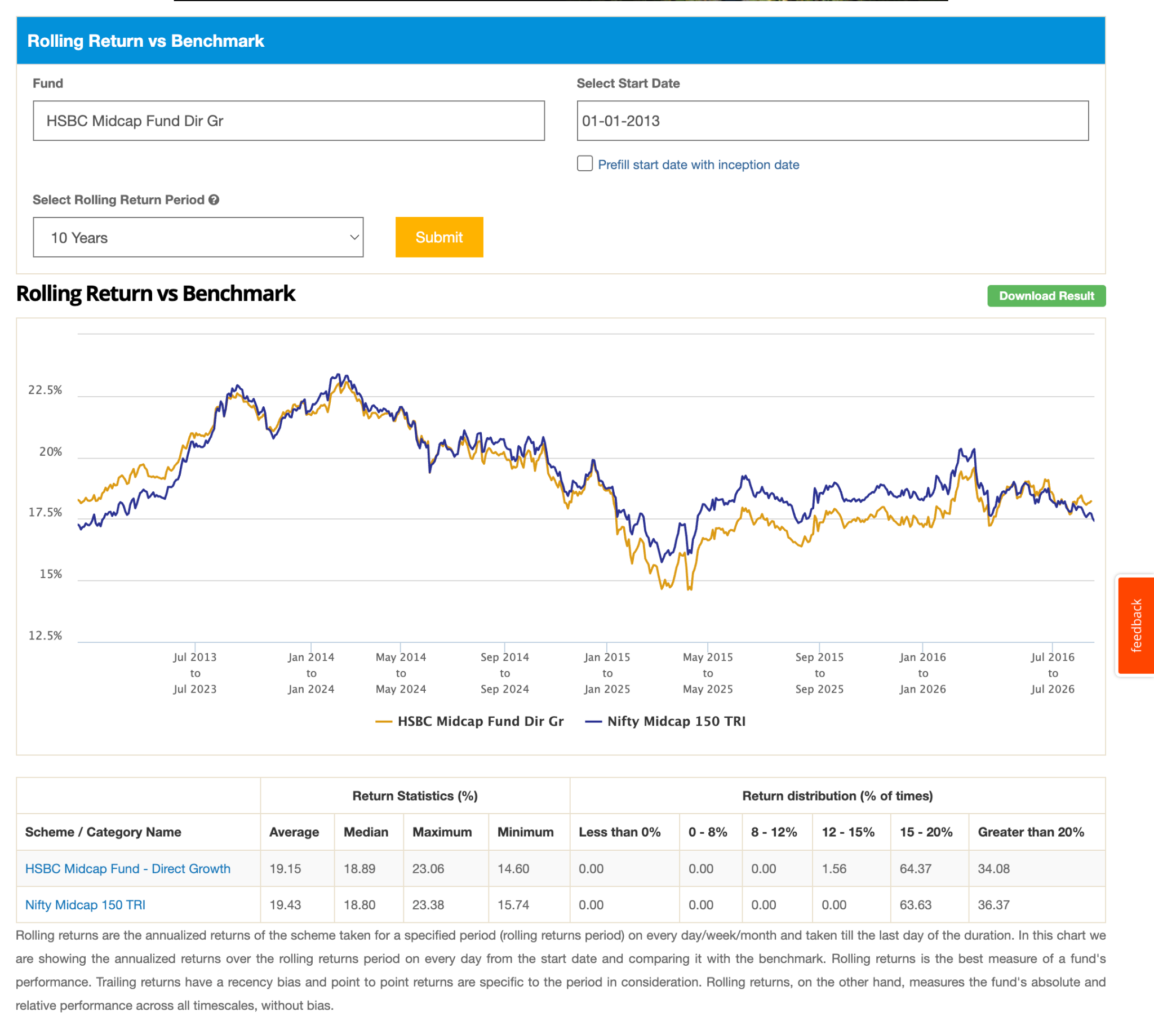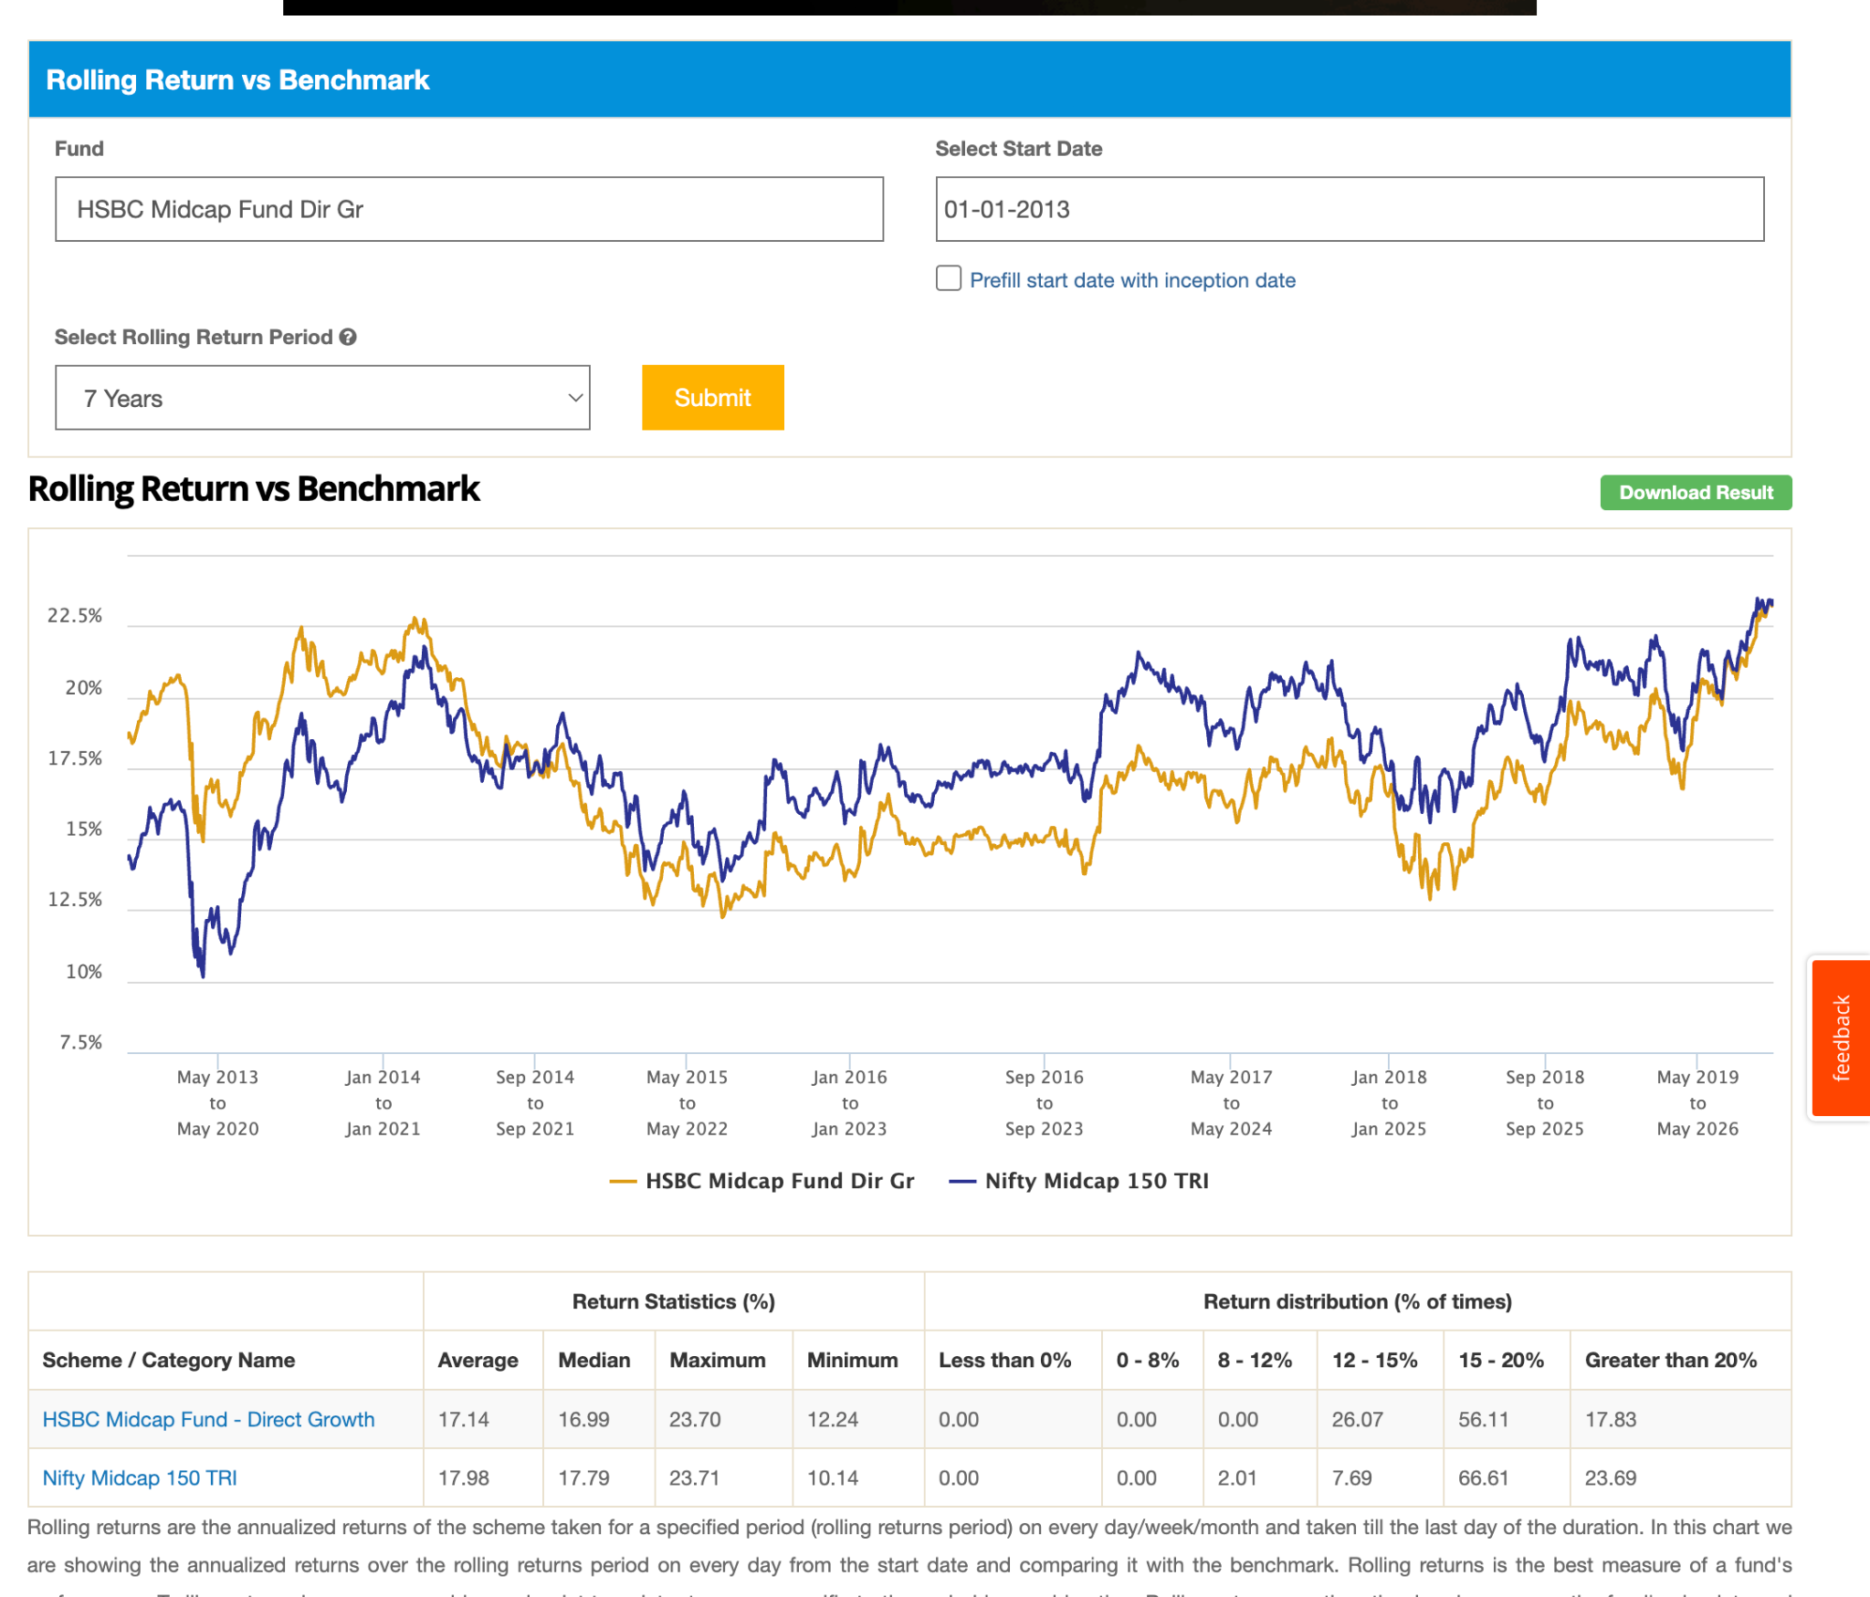. 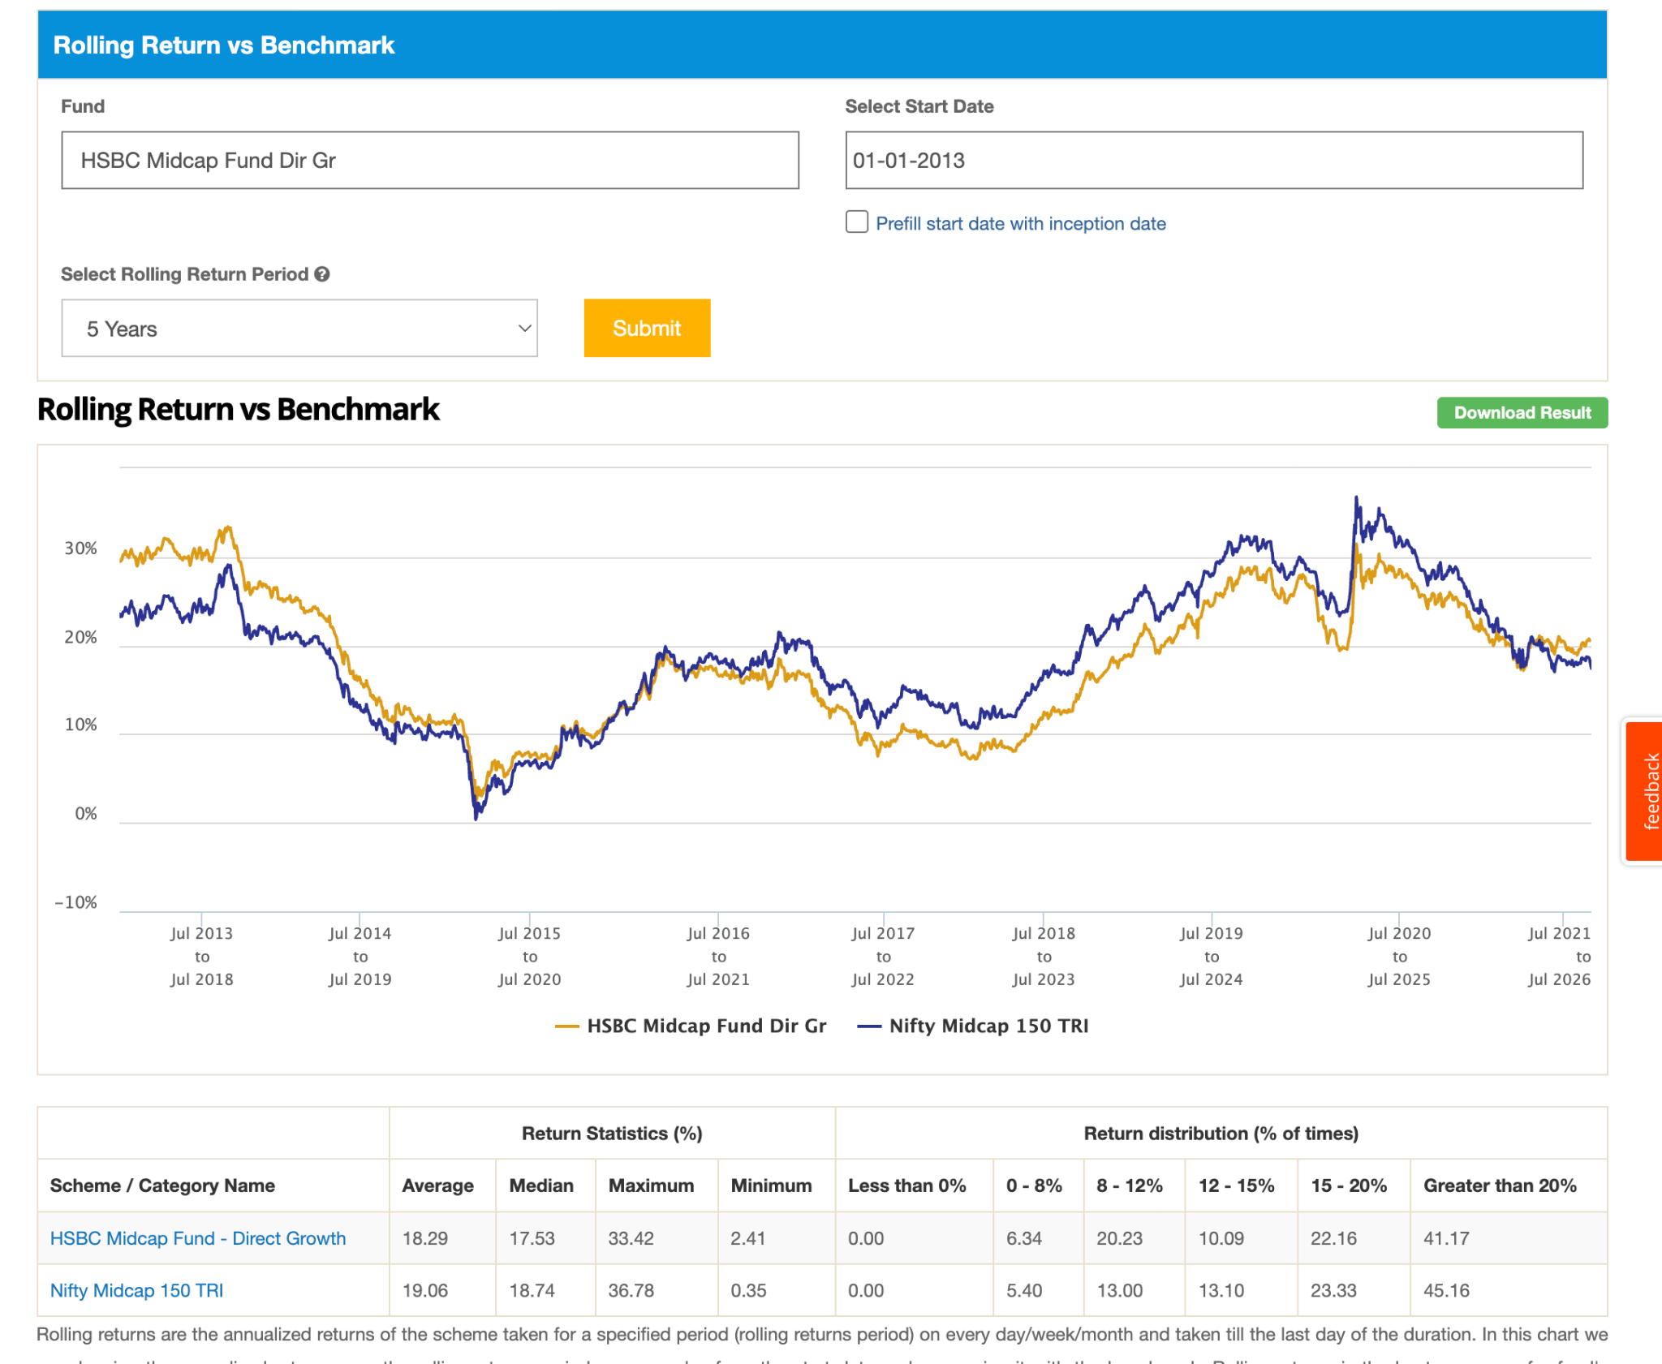
- So active fund are mostly good in 3-5y, they are like the intraday trading but day replaced by year or half year. here we need to shift one place to other. Its good way to generate alpha but its dependent on hardwork of investor as well. else in long term ( 10+ ) its not able to generate that good. but problem here is that we are comparing with benchmark how actual 150 index fund will work not sure , one thing is sure 0.5 if expense ratio then percent will be reduced by 0.5 definitely, how they will perform on bare no idea.

-

Category 3: ( all are beating/touch uptil now ):
out of all:
- icici touching. 8k -> not good mostly trying to reach either able to touch or beat. in 10y, in 7 50%, less touching, not beating > 70%. this kind of fund you don't want and can prefer a midcap 150 index. or in the worst case if I did not regret.
- Mirae ( 2019 ) . in 7y touching perfectly. in 5 years touching only, in 3 touching and below. also the same as icici, why take so much tension and just for touching index. also getting down when index is down.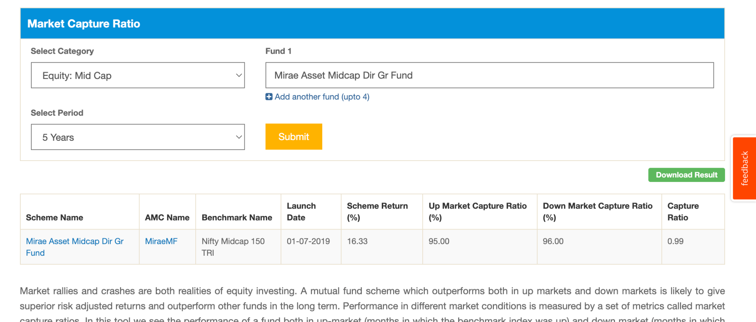
- Motilal -> 60-70% beating. ( -36.1 in corono, no downside that much ) , after corono became decent before that 2-3% below after that increase , dicy.
- hdfc -> 70 ( beating in 10y mostly ), in 10y in last 5y just beating index ( may be after definatin , before that margin was good ) . in 7y just touchin/beat same in 5 y. one thing is notice it either outperform bit ( not very high margin ) or touch never get touch than index. good for index not very idea but definitely good. excep some time in 2/3 year 20-30%/100% . in covid -35.1. so these guys are not giving cushion that much which i was thinking.
- kotak -> satisfying. > 70% . covi -34.6 . kind of same as hdfc, excep 2/3/5 its low ( ~0-3% ) . in 10y kotak beat hdfc. same in 7 touch or beat. from 5 started reducing seems like last 3-5 year wasn't good for this. 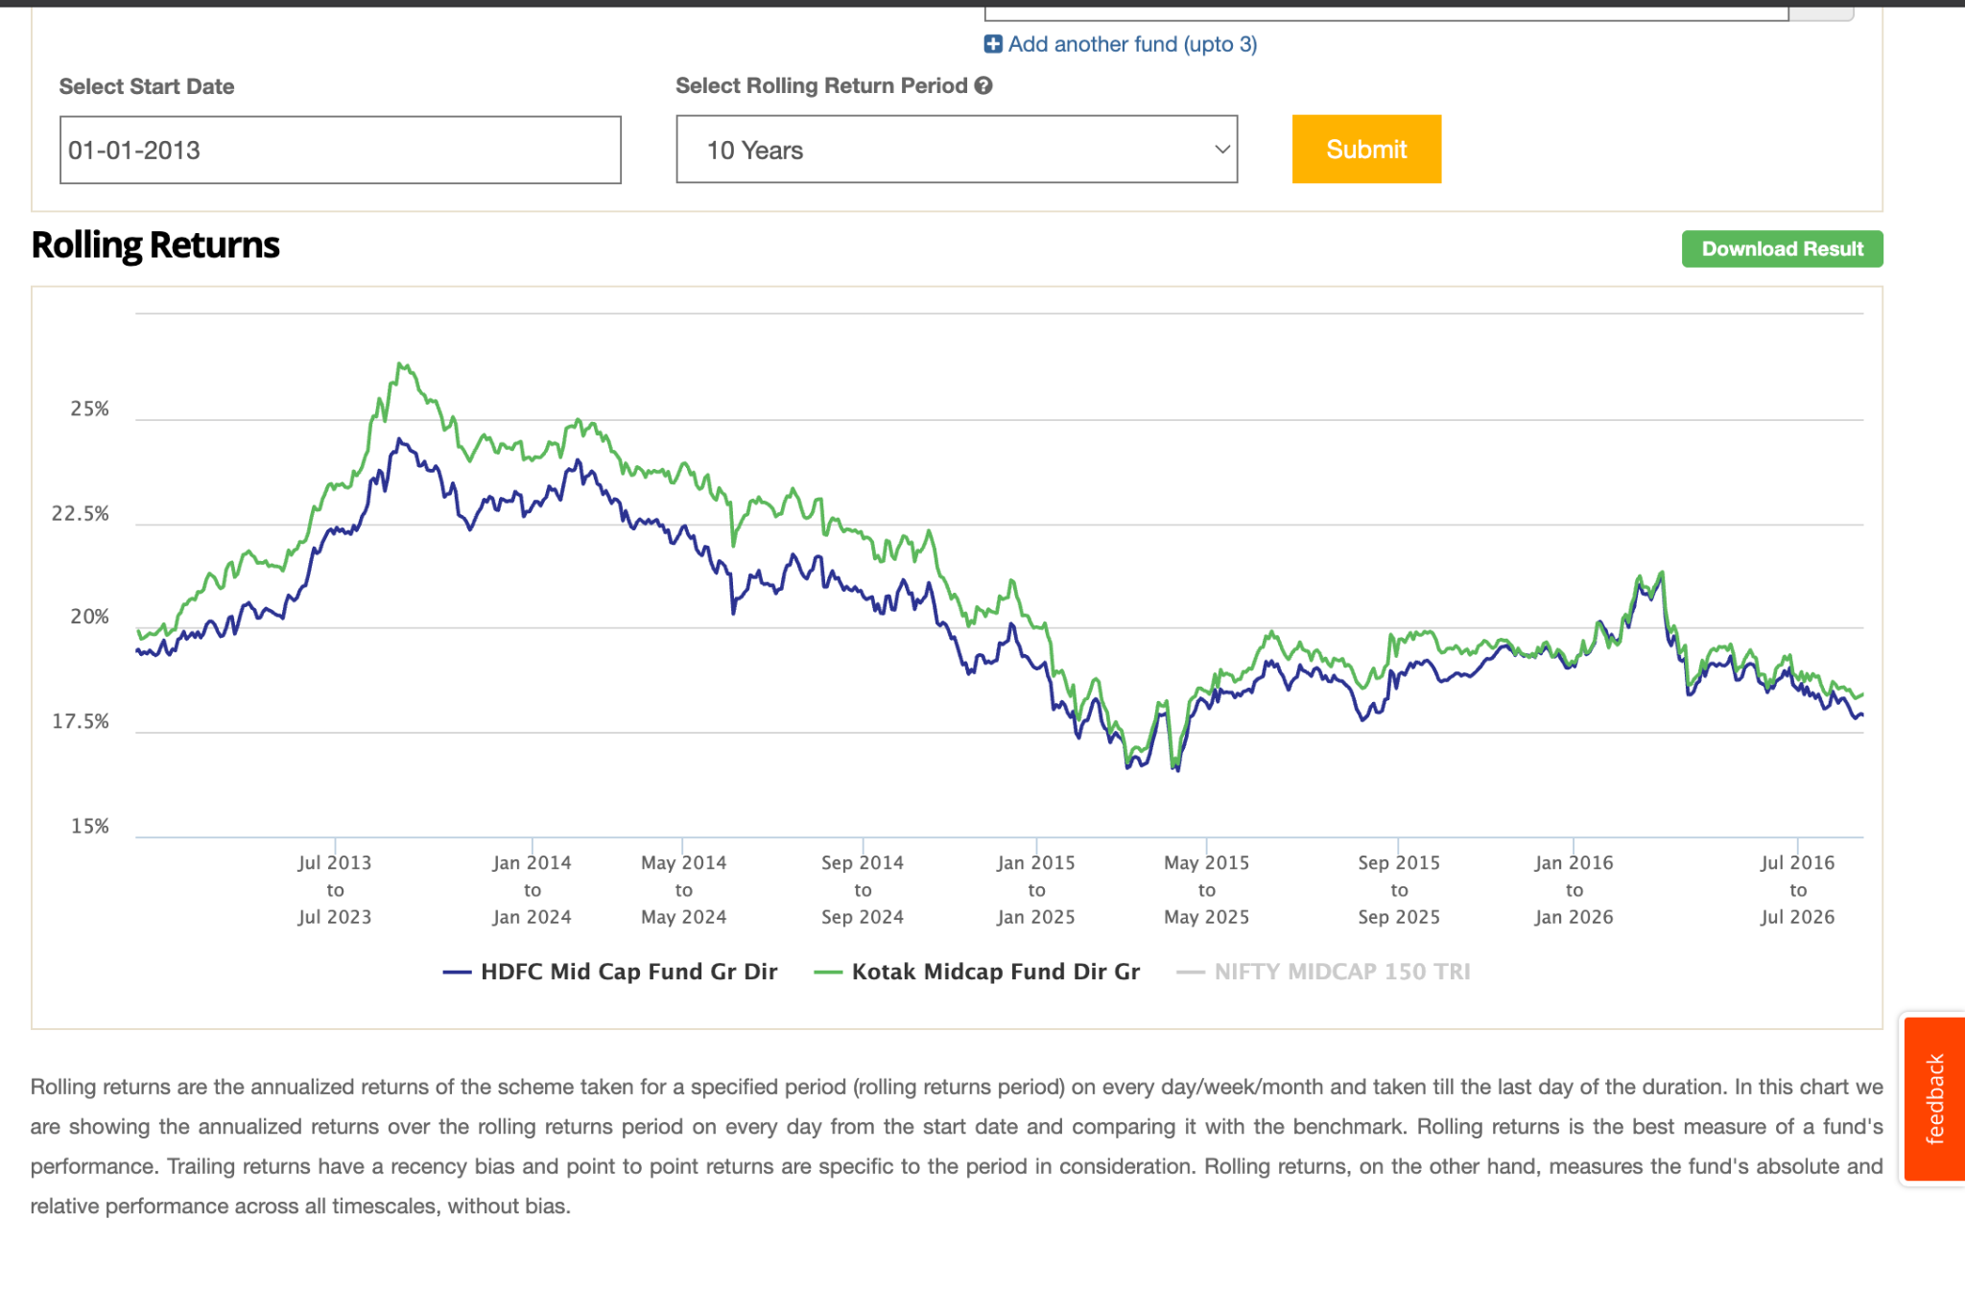
- edelseisis -> 17k 10y beating, 7y also, 5y also ( 2-3%, in 5 year 2.5% -> 50k monthy -> its 15lakh diff ) this looks overall idea fund: thats why people go to activ, but in time of corono ( this went -34.9, index - 36.3. so no that much cushion :) ) 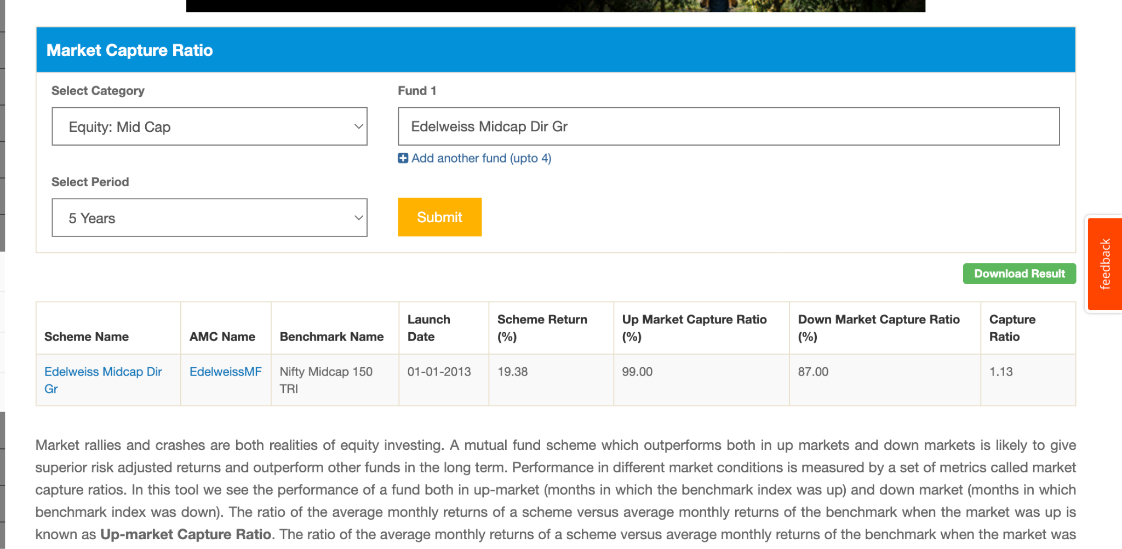
- invesoc -> 10y beating, 7y also, 5y also ( ~0-3% ) . in 2/3 sometime 30%/100 bit below than benmark. => -32.60 corno ( one of the best uptil now )
- axis -> 50%, not working well 5y last. ( -27.47 -> woww best uptil now ) , after 2020 something bad happen before that i was fine as other. 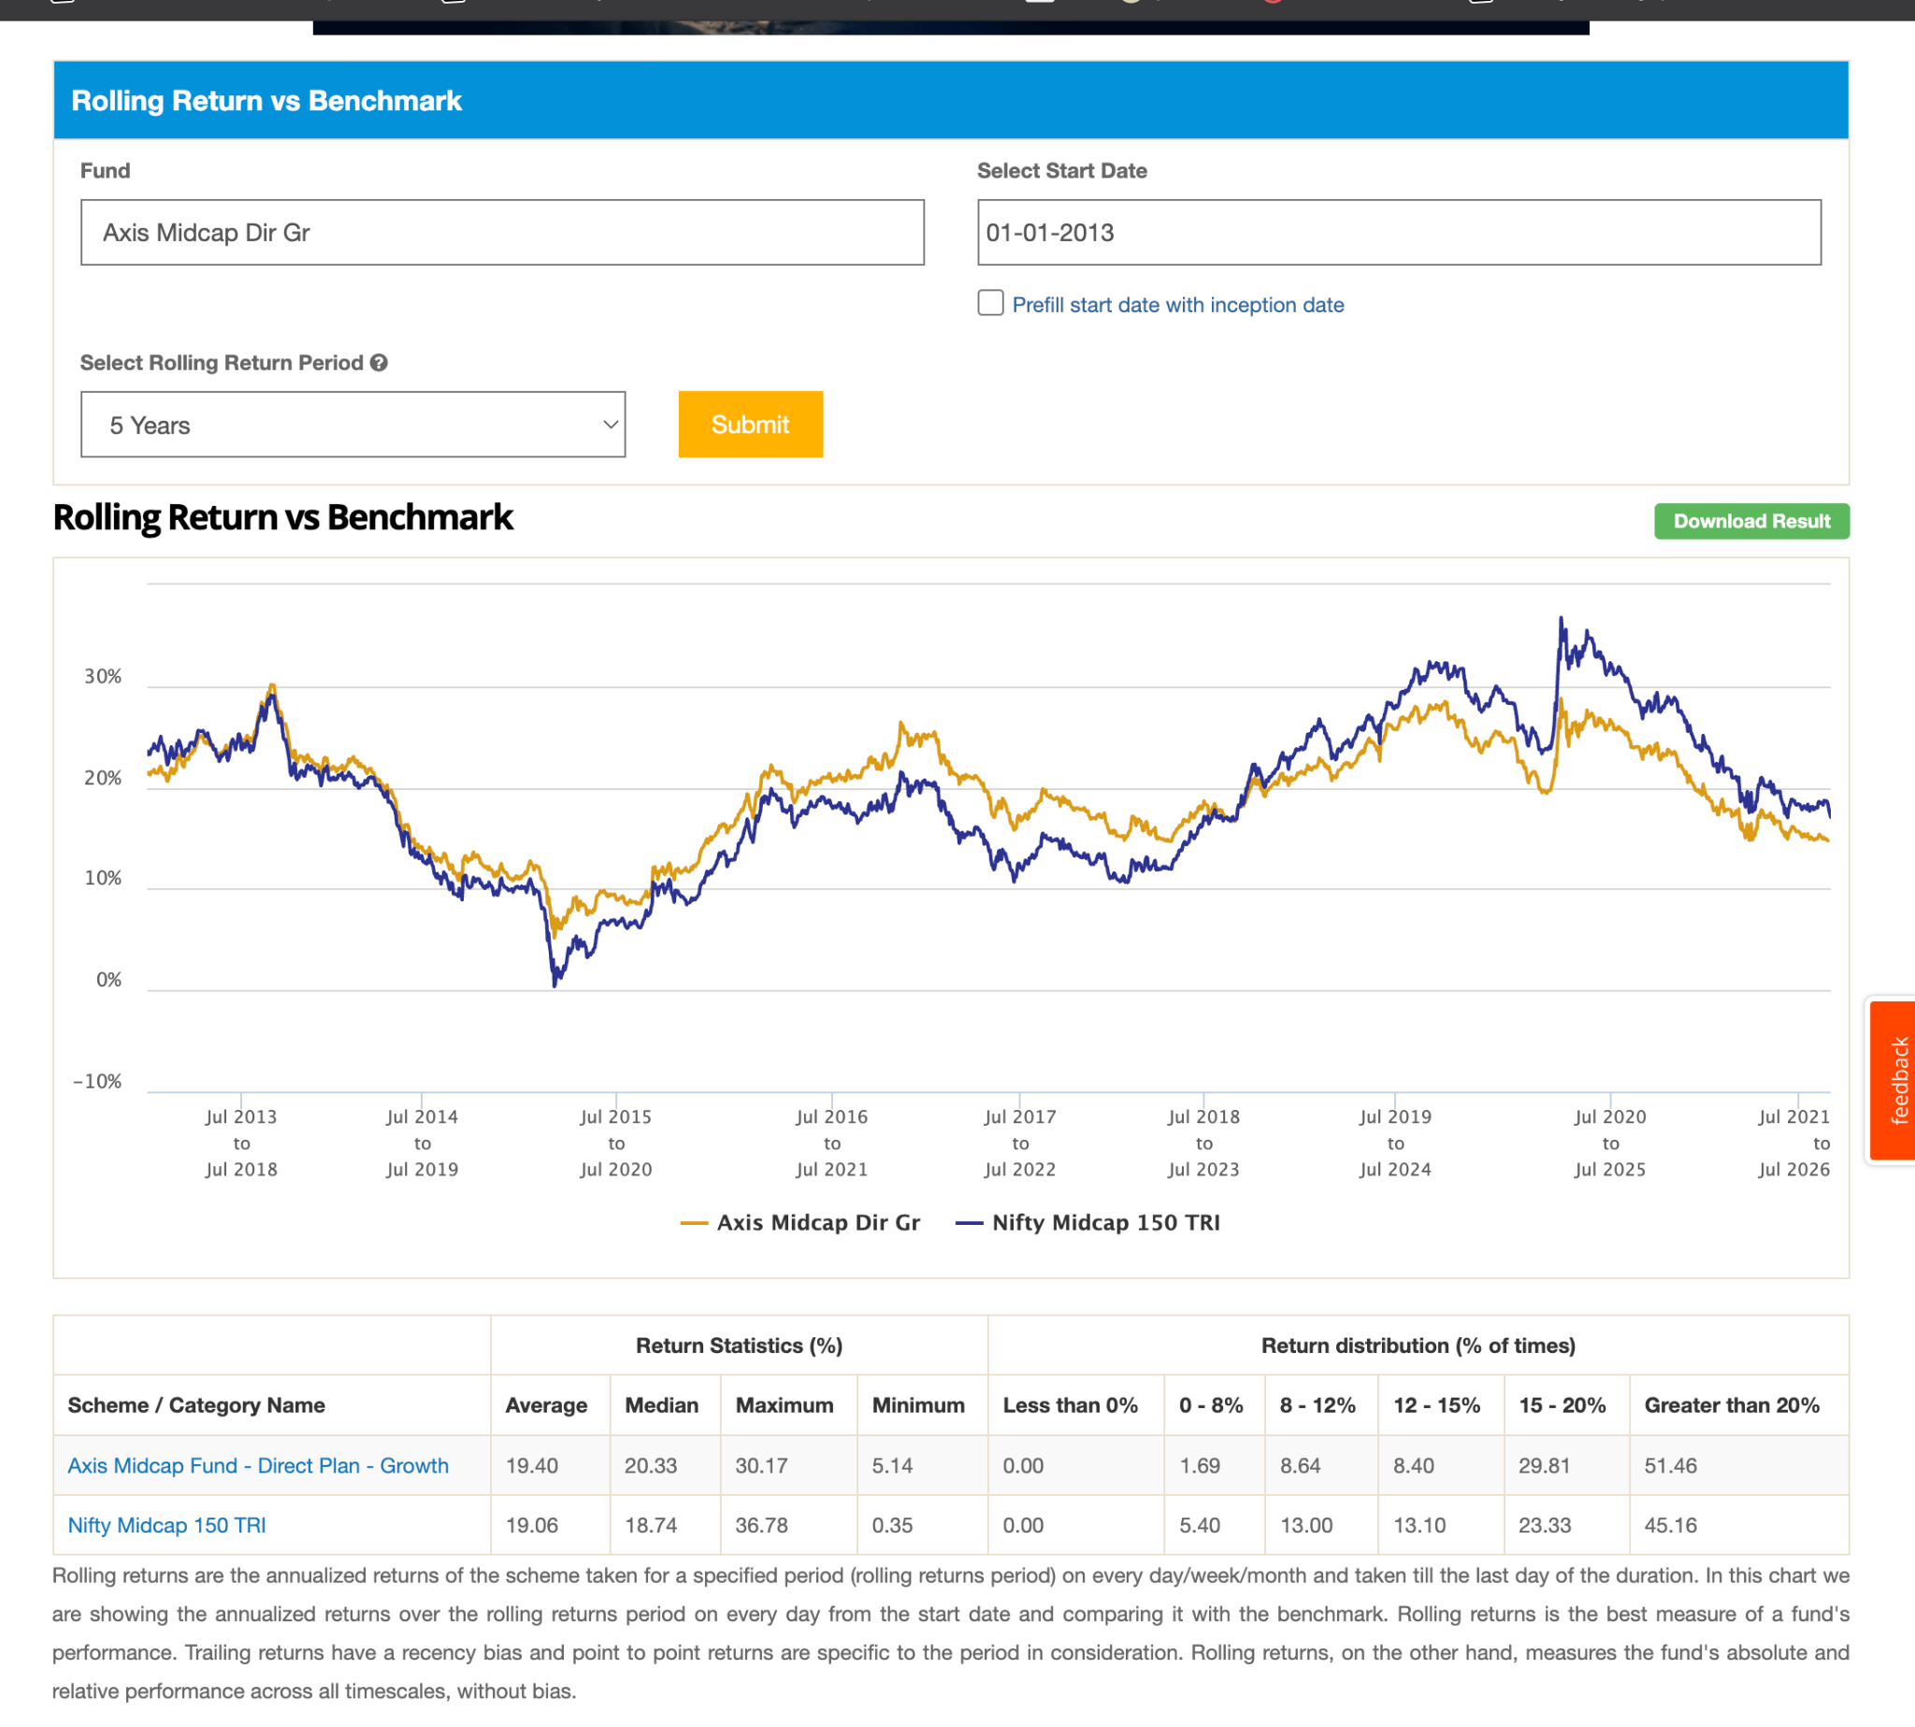
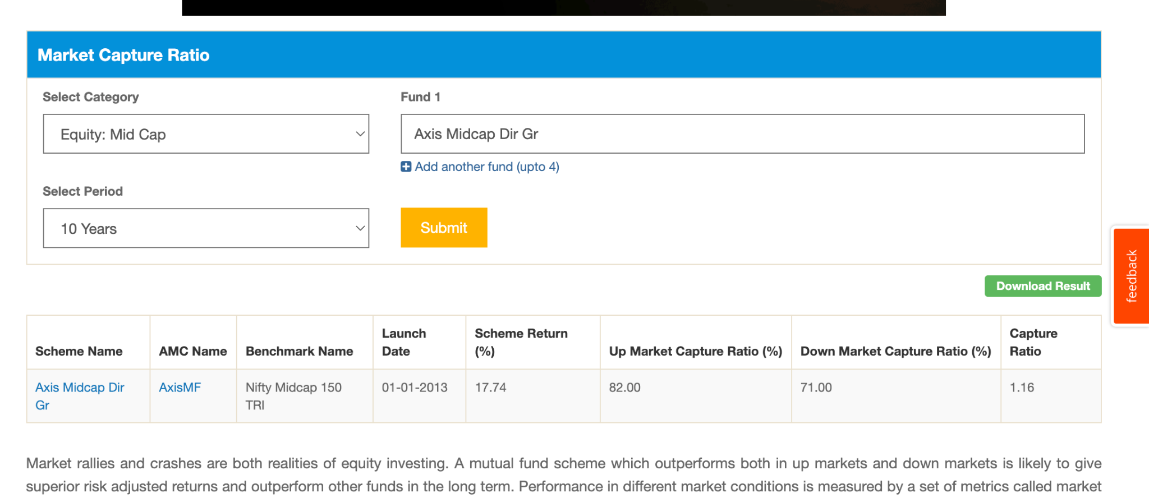
- nippon -> after corona beating. ( -33.69 ) , before that i was touching or below. 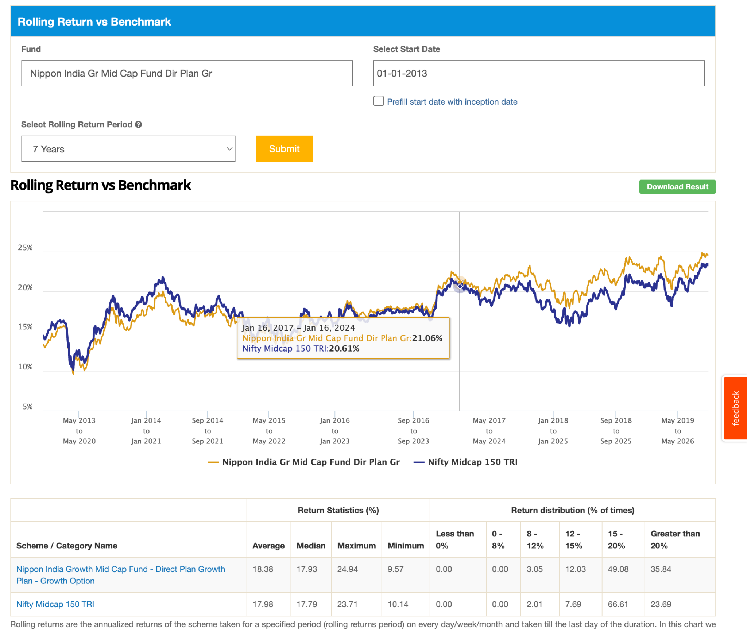
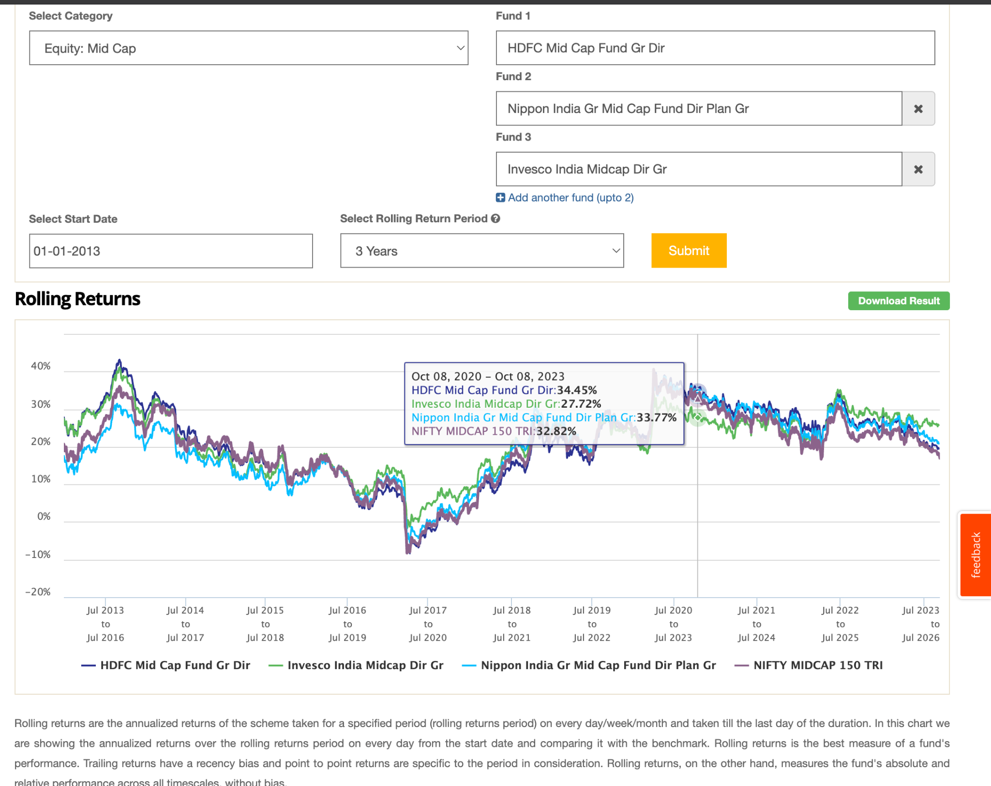
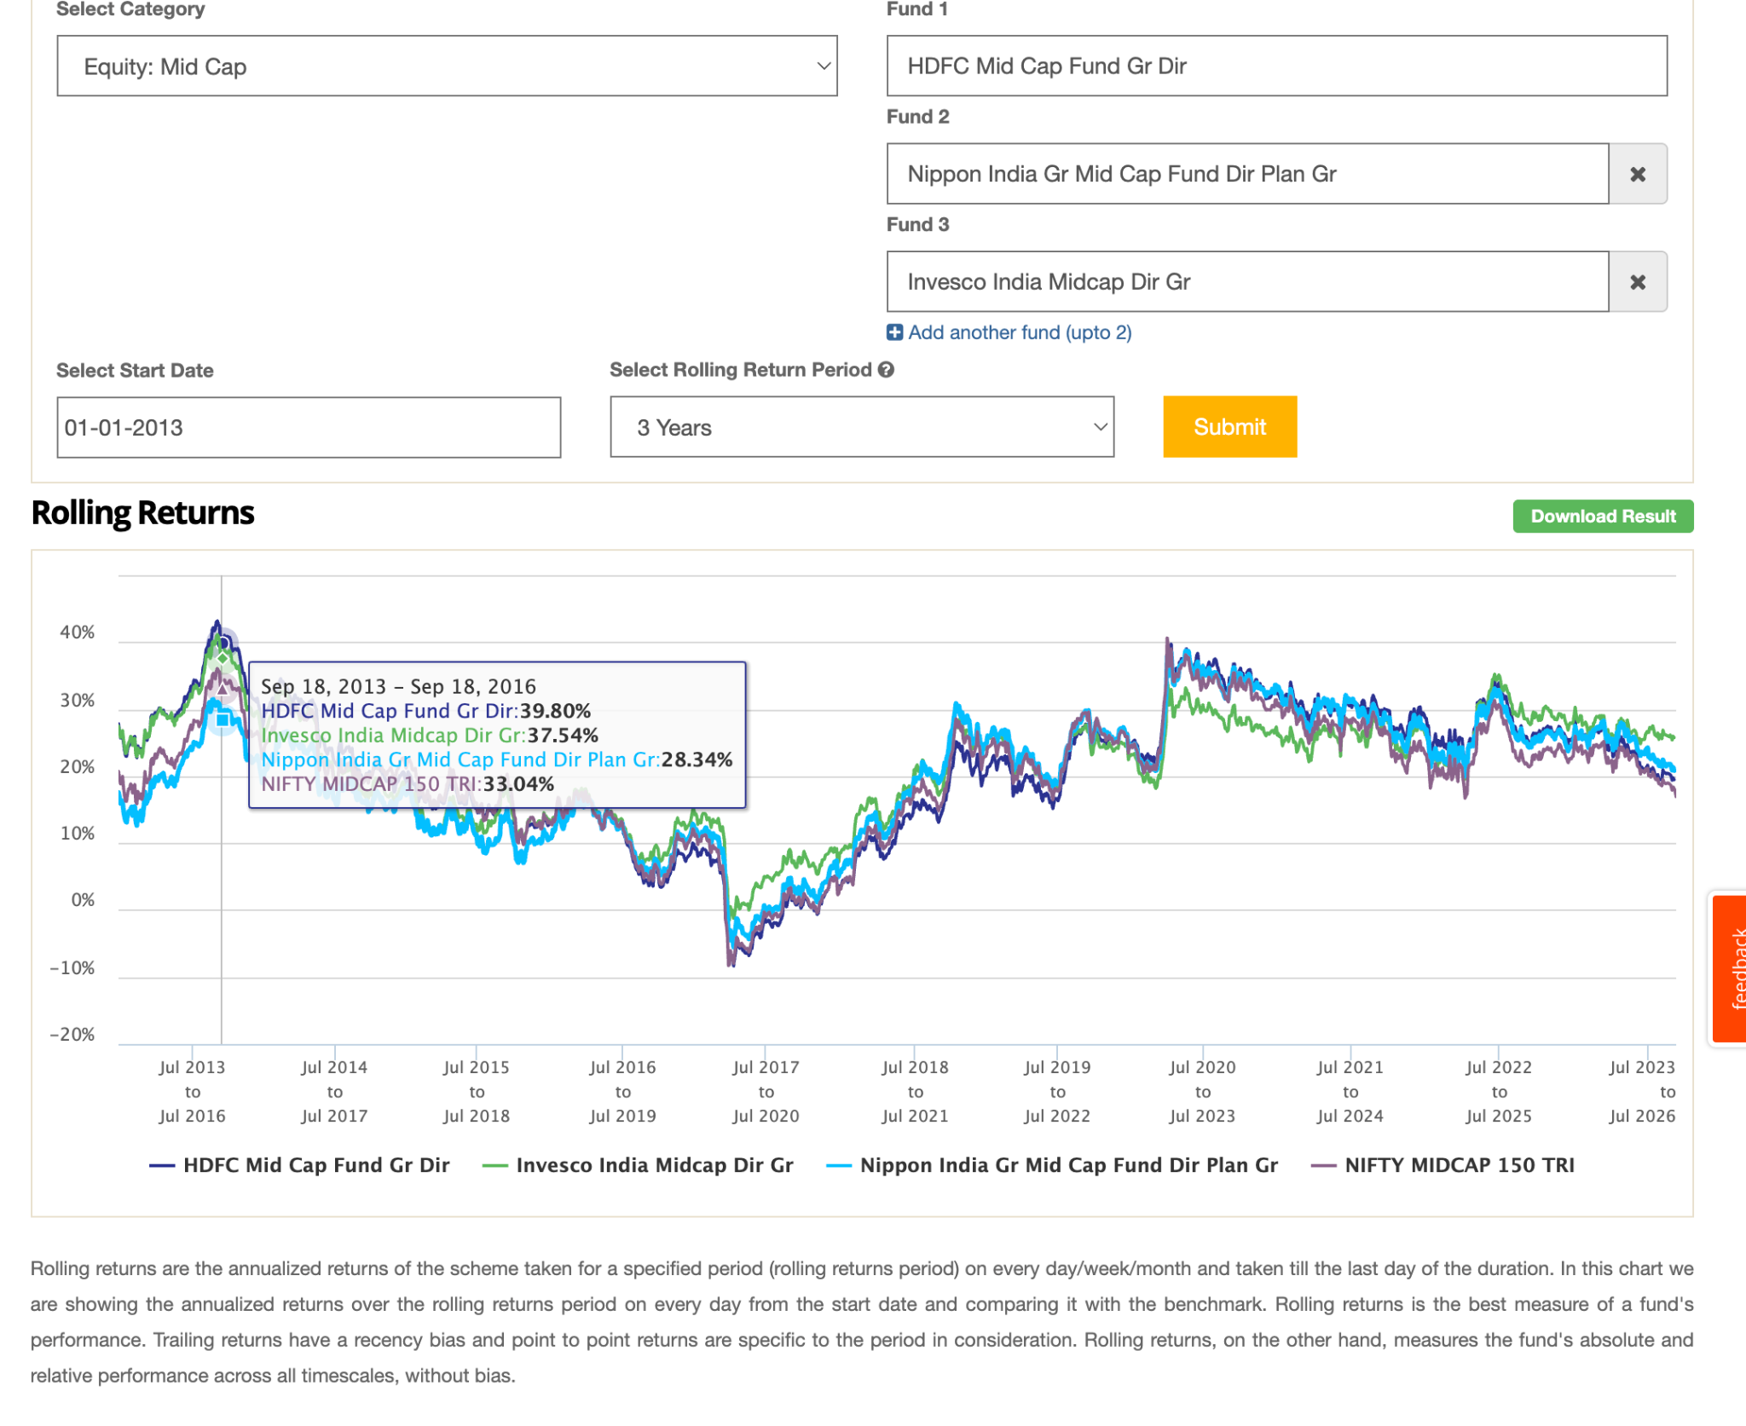
.......................................................................................................................................

- Seems like in ideal case whne you are able to predict best mid cap then you'll be able to make 0-3% than index.

- either index only.
- active only
- or mix of both and how much proportion
- motillal oswal 150midcap -> ( deep dive on this as well doc, how bull vs bear etc )
- edelwesis, hdfc, invesco, nipon, axis, whiteoak, kotak, motilal etc whoever is most consistent, low down, no volatile, good aum fundmanger, good rolling, less expensive, etc.
- keep ratio 35:65 ( active/passive )
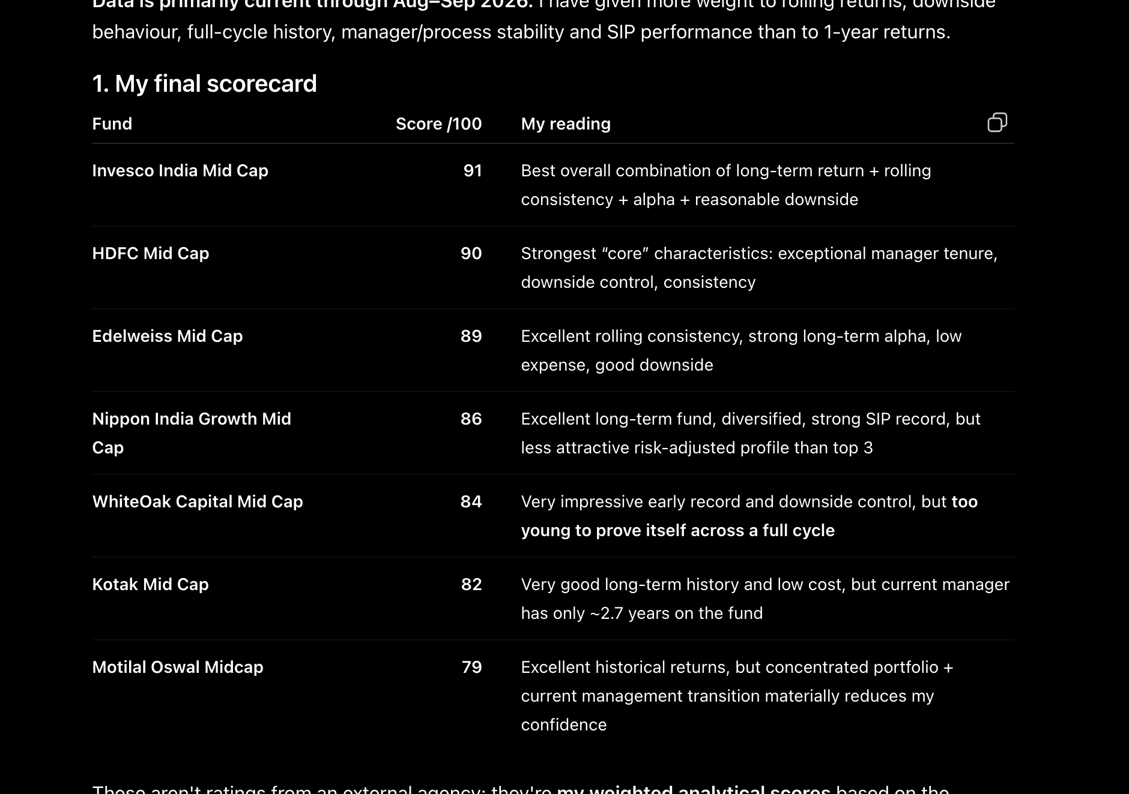
Select Out of :
1. Edeweiss ( has 45% overlapping with nippon, so nippoin and this can't take , keeping this as compare to nippon. )
2. HDFC ( great fund manager, big )
3. invesco ( good fund manager, this is also concentrated, but not that technology, fund seems good consistent , less volatile, consitent, bit cyclic , taking this ) 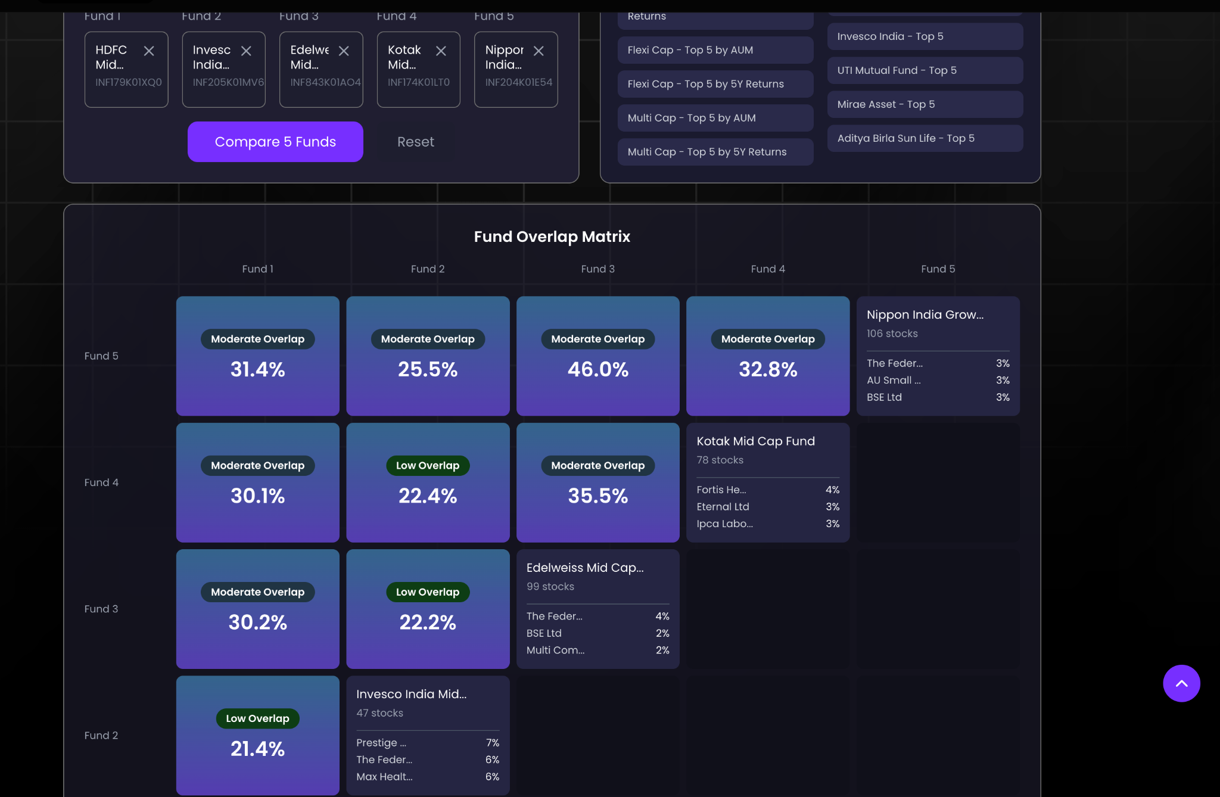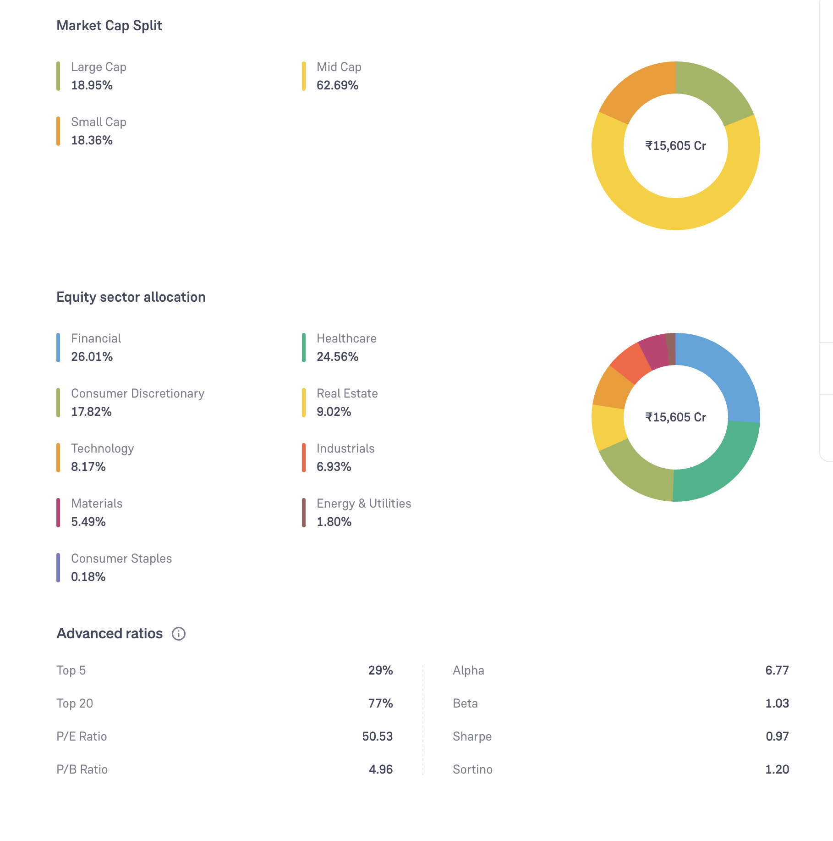
4. nippon ( Rupesh patel good, in 10y it was less or close t hdfc, not taking this as more ore less similar to hdfc, hdfc seems better good fund manager, and it has 46% overlapping iwth edeilsisis has betett perf. 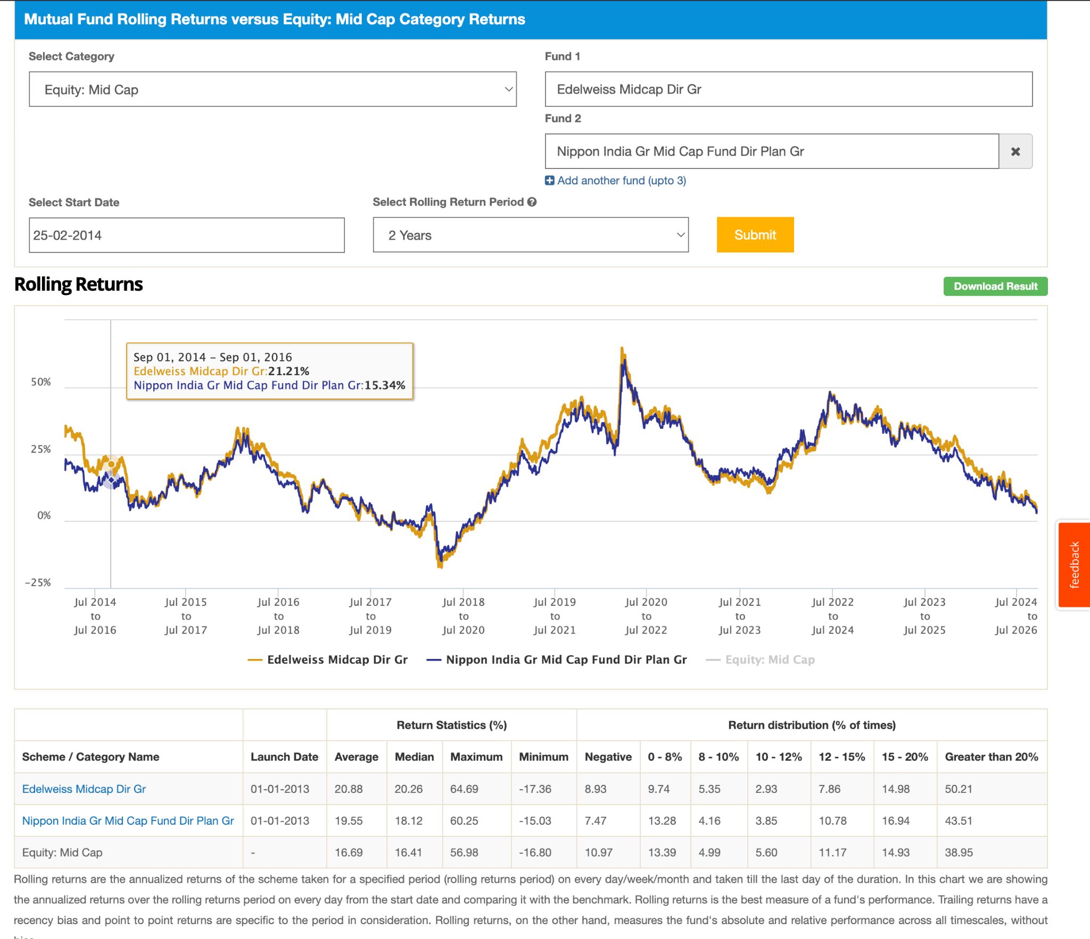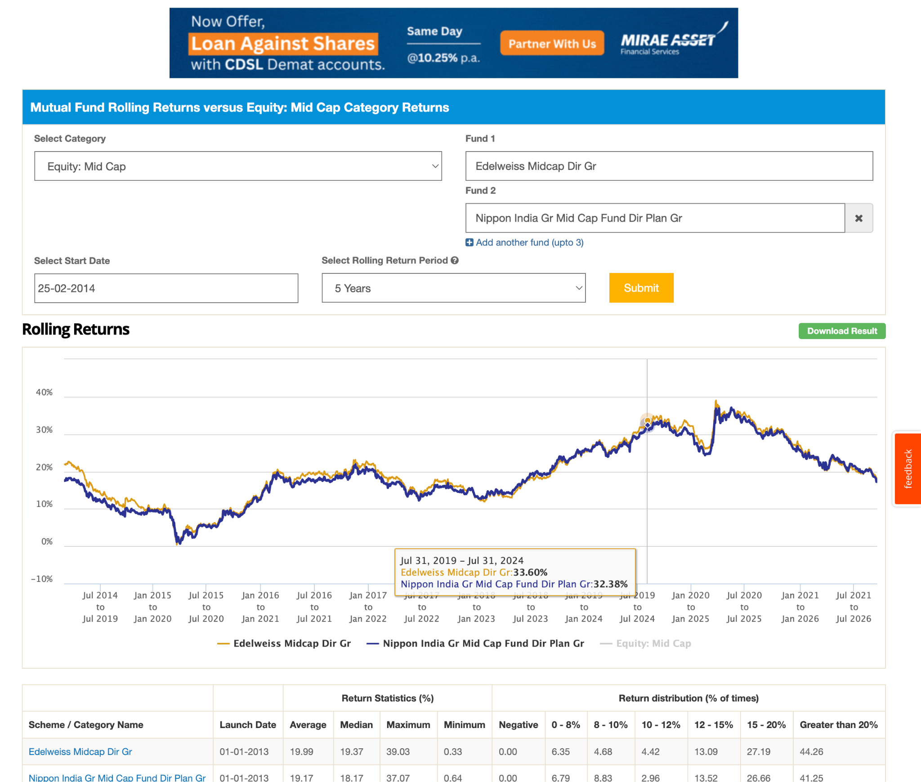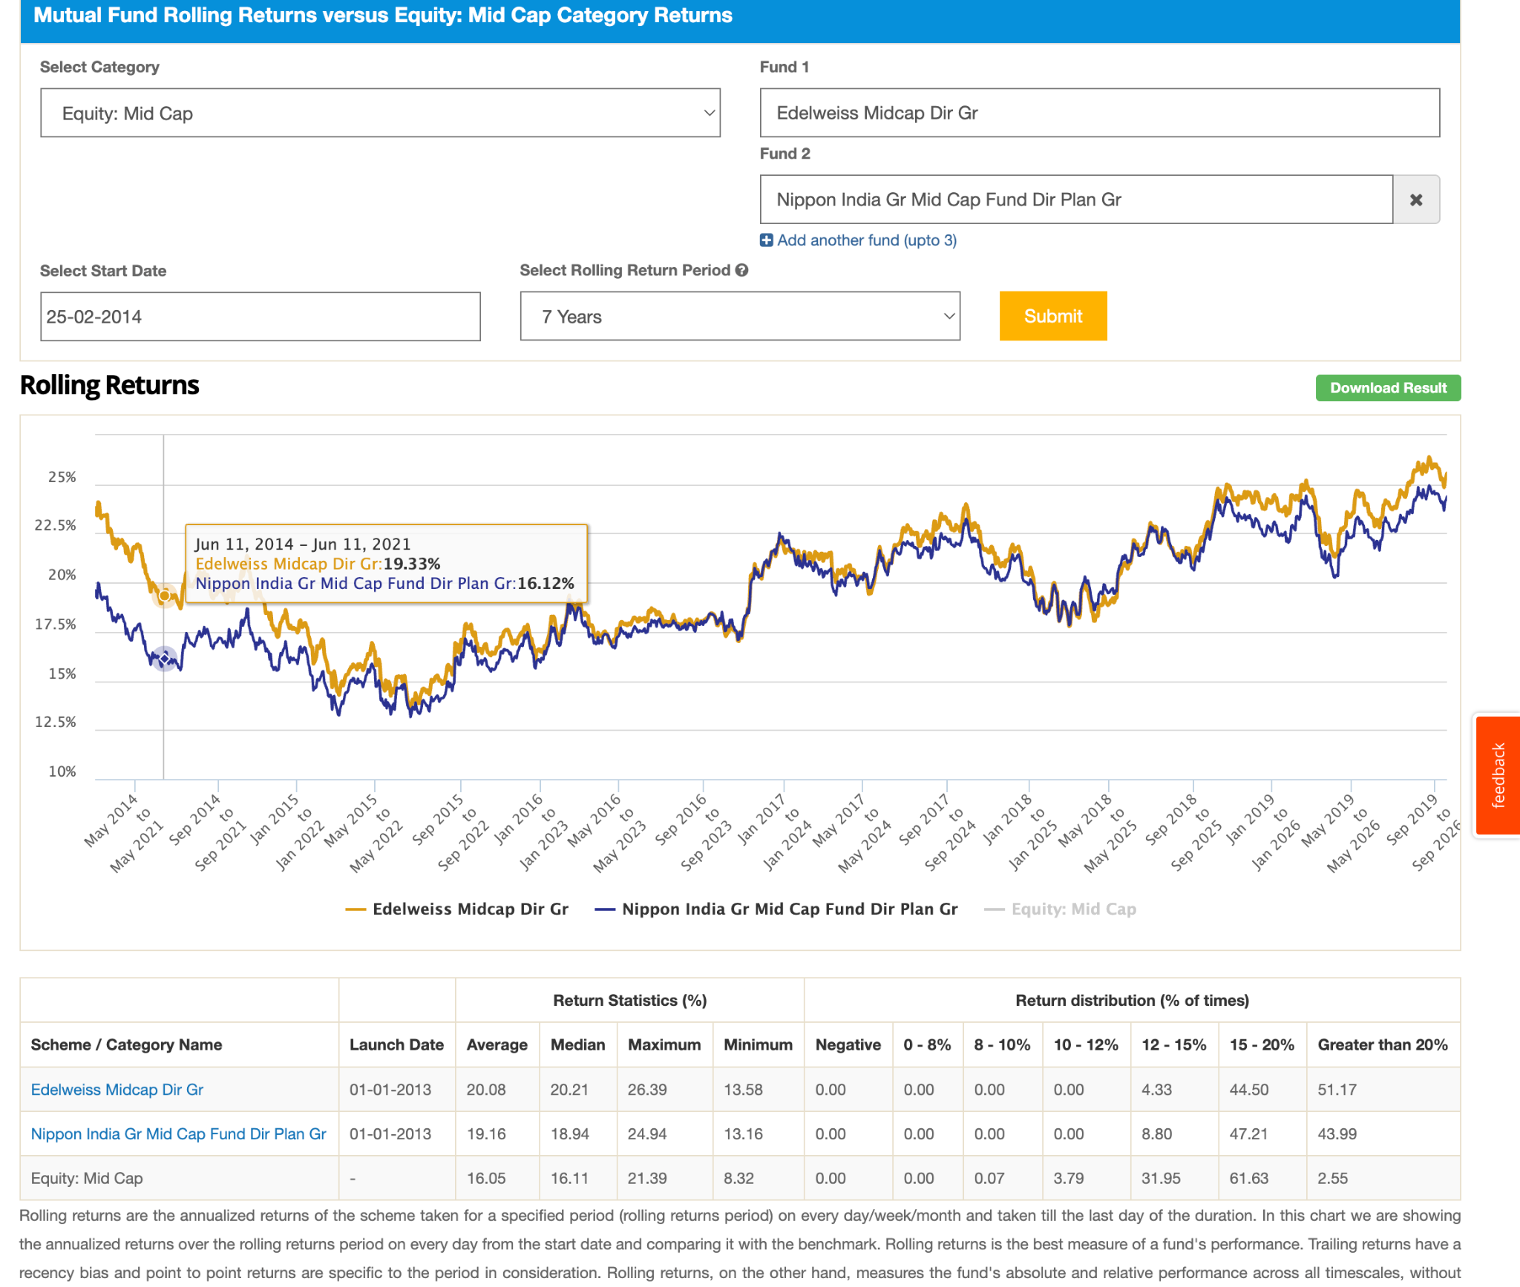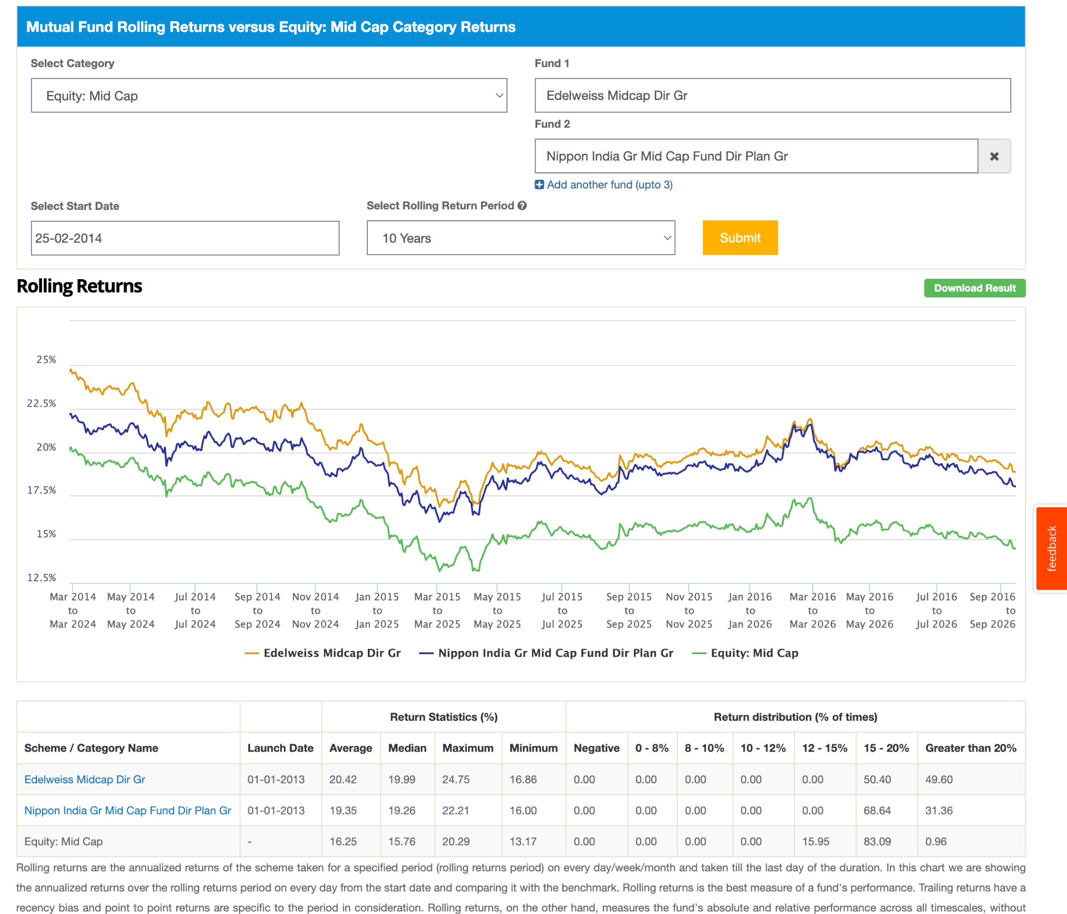 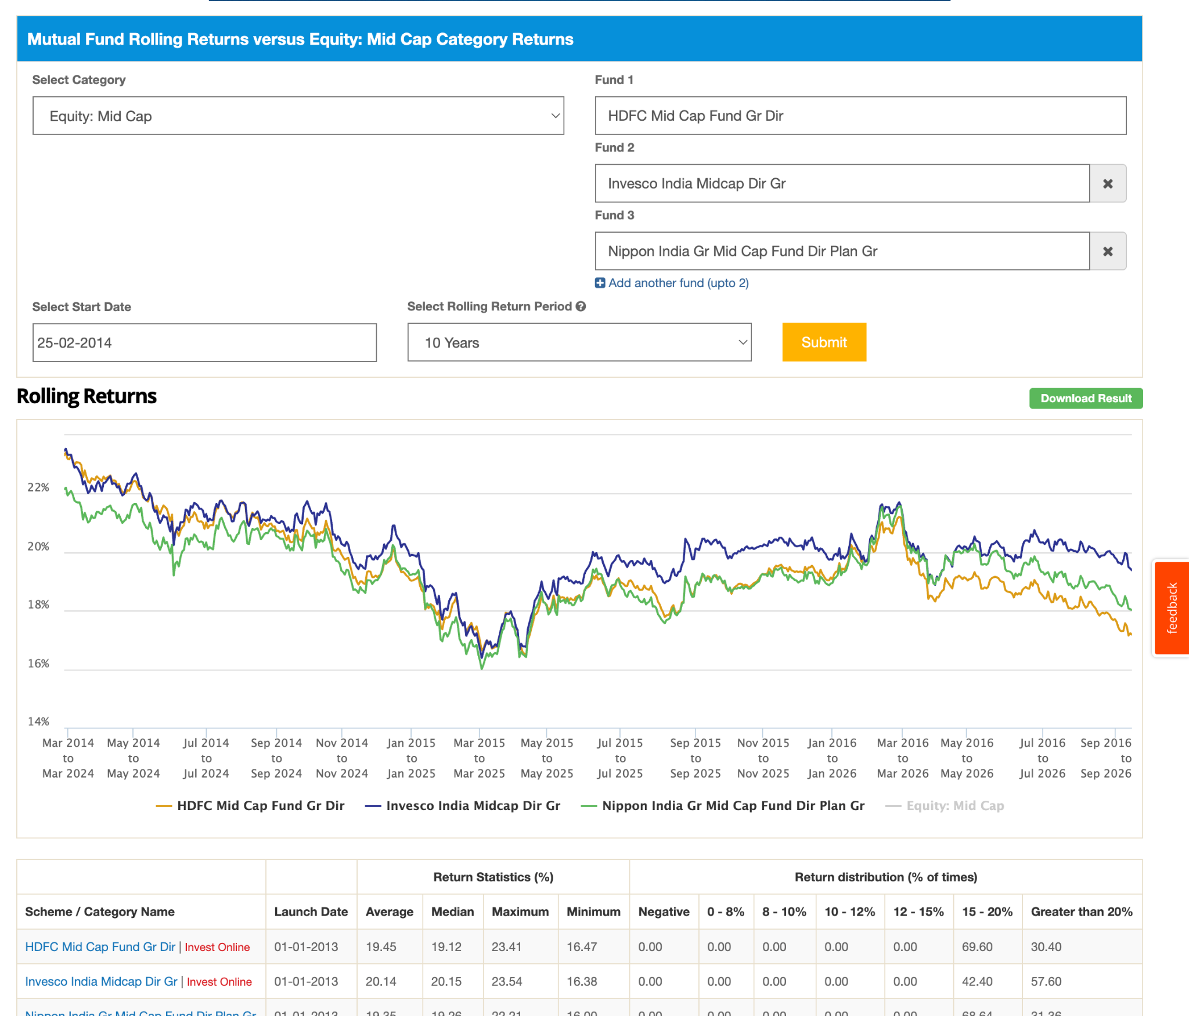
8. motilal ( observation , yet to be decided
- too concentrated 32 stocks,
- technology heavy , 80+ mid cap actuall mid cap allocation. ( other 60s )
- high volatile.
- high upside capture ratio and high downside ( mean if down the good down not save )
- its a different type of fund we can deep dive into this can book profit right now like invest now and book profit after 2-3y when the cycle hit. 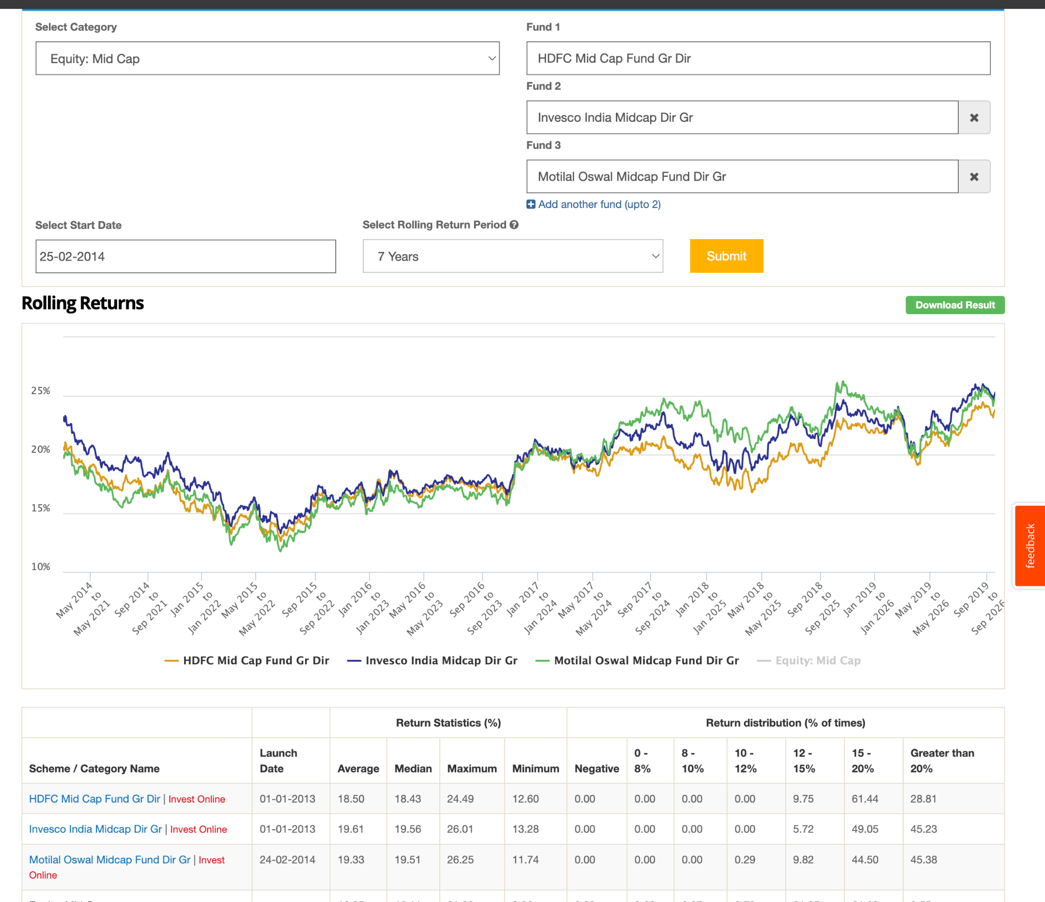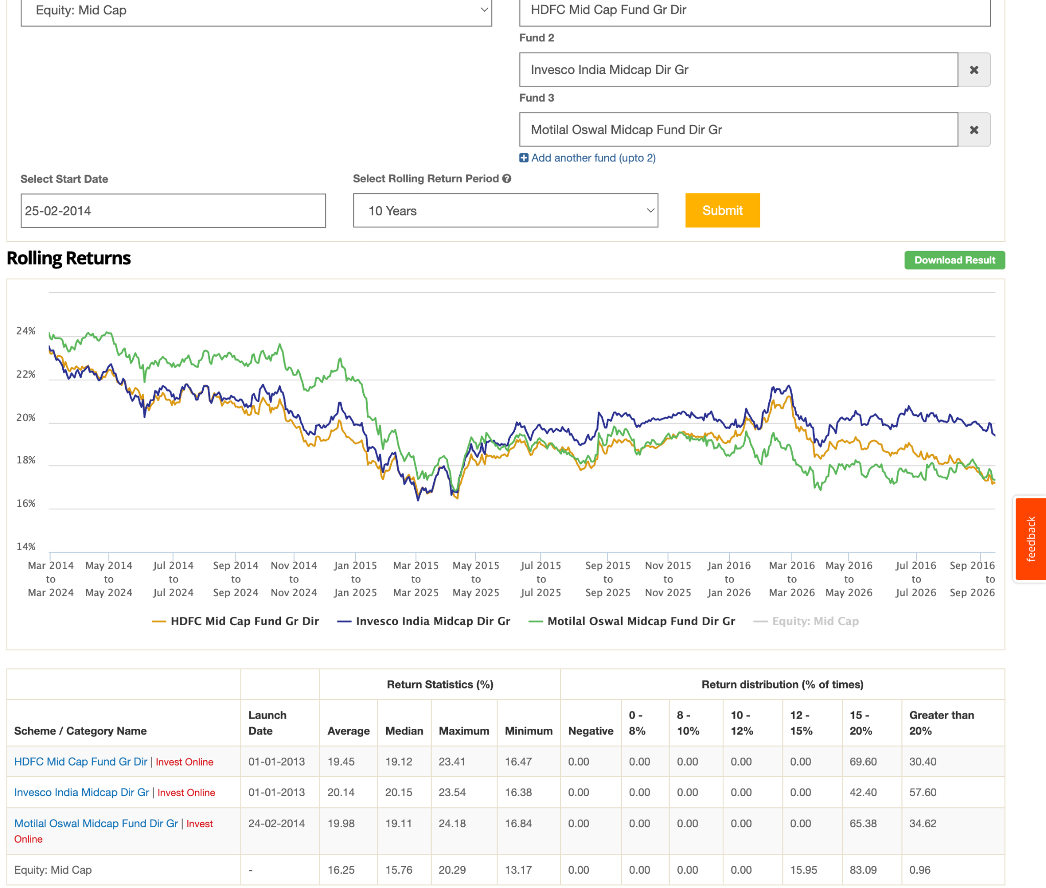
-
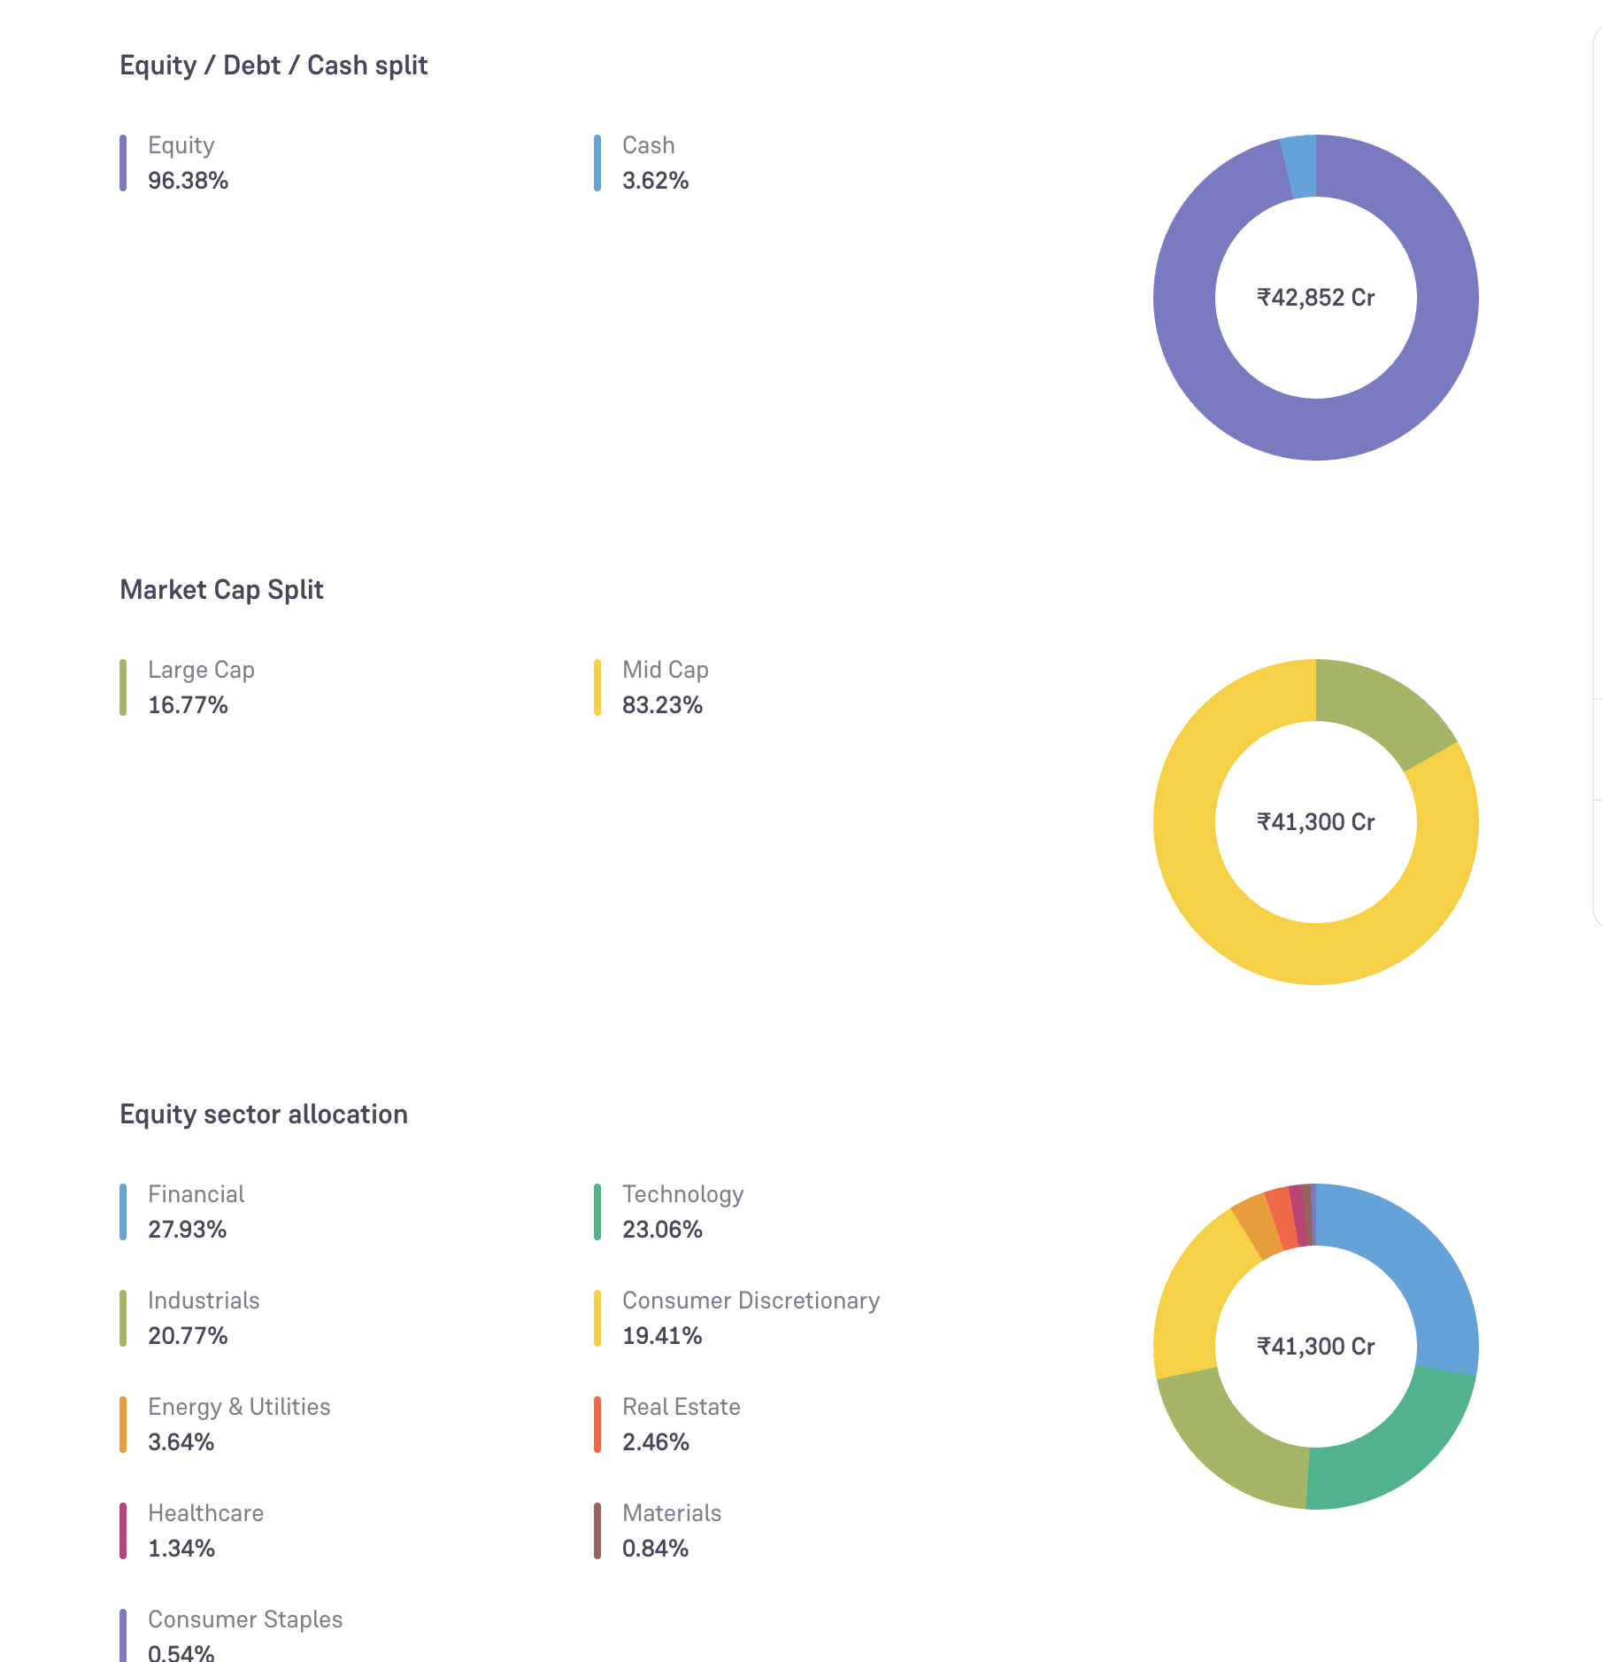
9. kotak ( new fund manager change ,atul bhole relatively less quality team, its better to do at hdfc since both are large. keep monitoring not taking this time. )
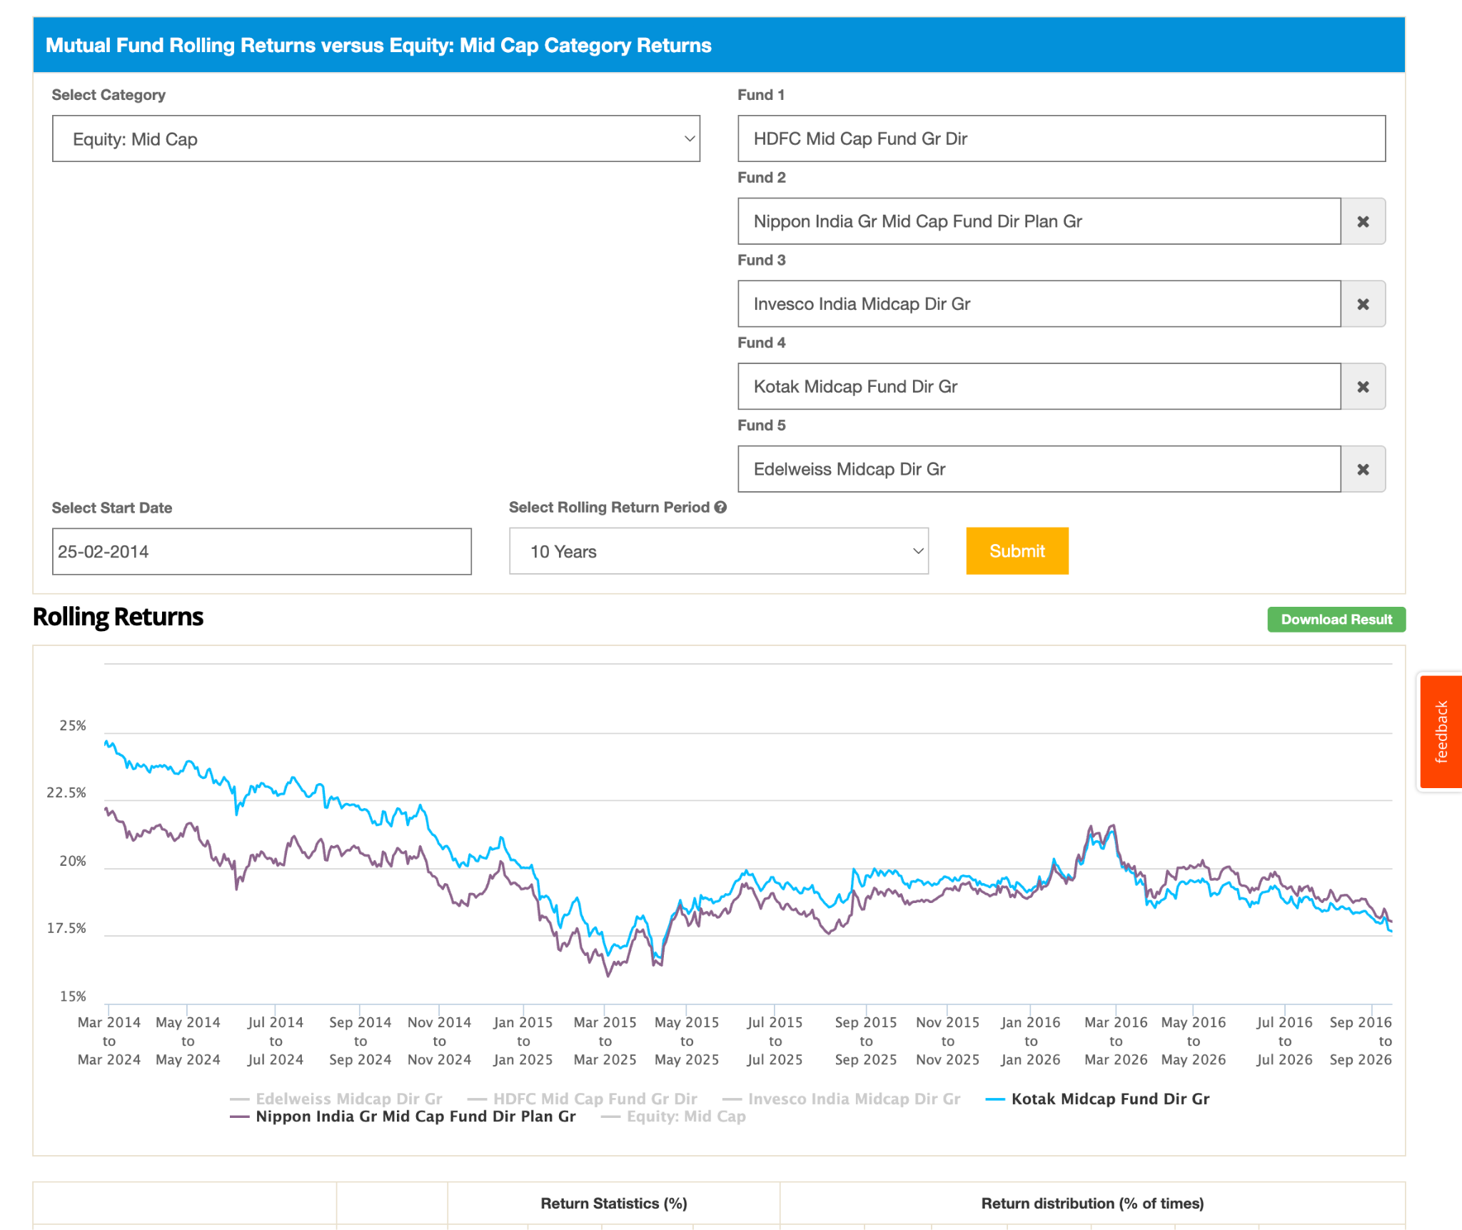
10. hsbc ( currently working well but not in pass consistenly, keeping at monitor but nto investing. proof attached. recently just increasing. high expense ratio, though people added ~2k crore in august in this. ) 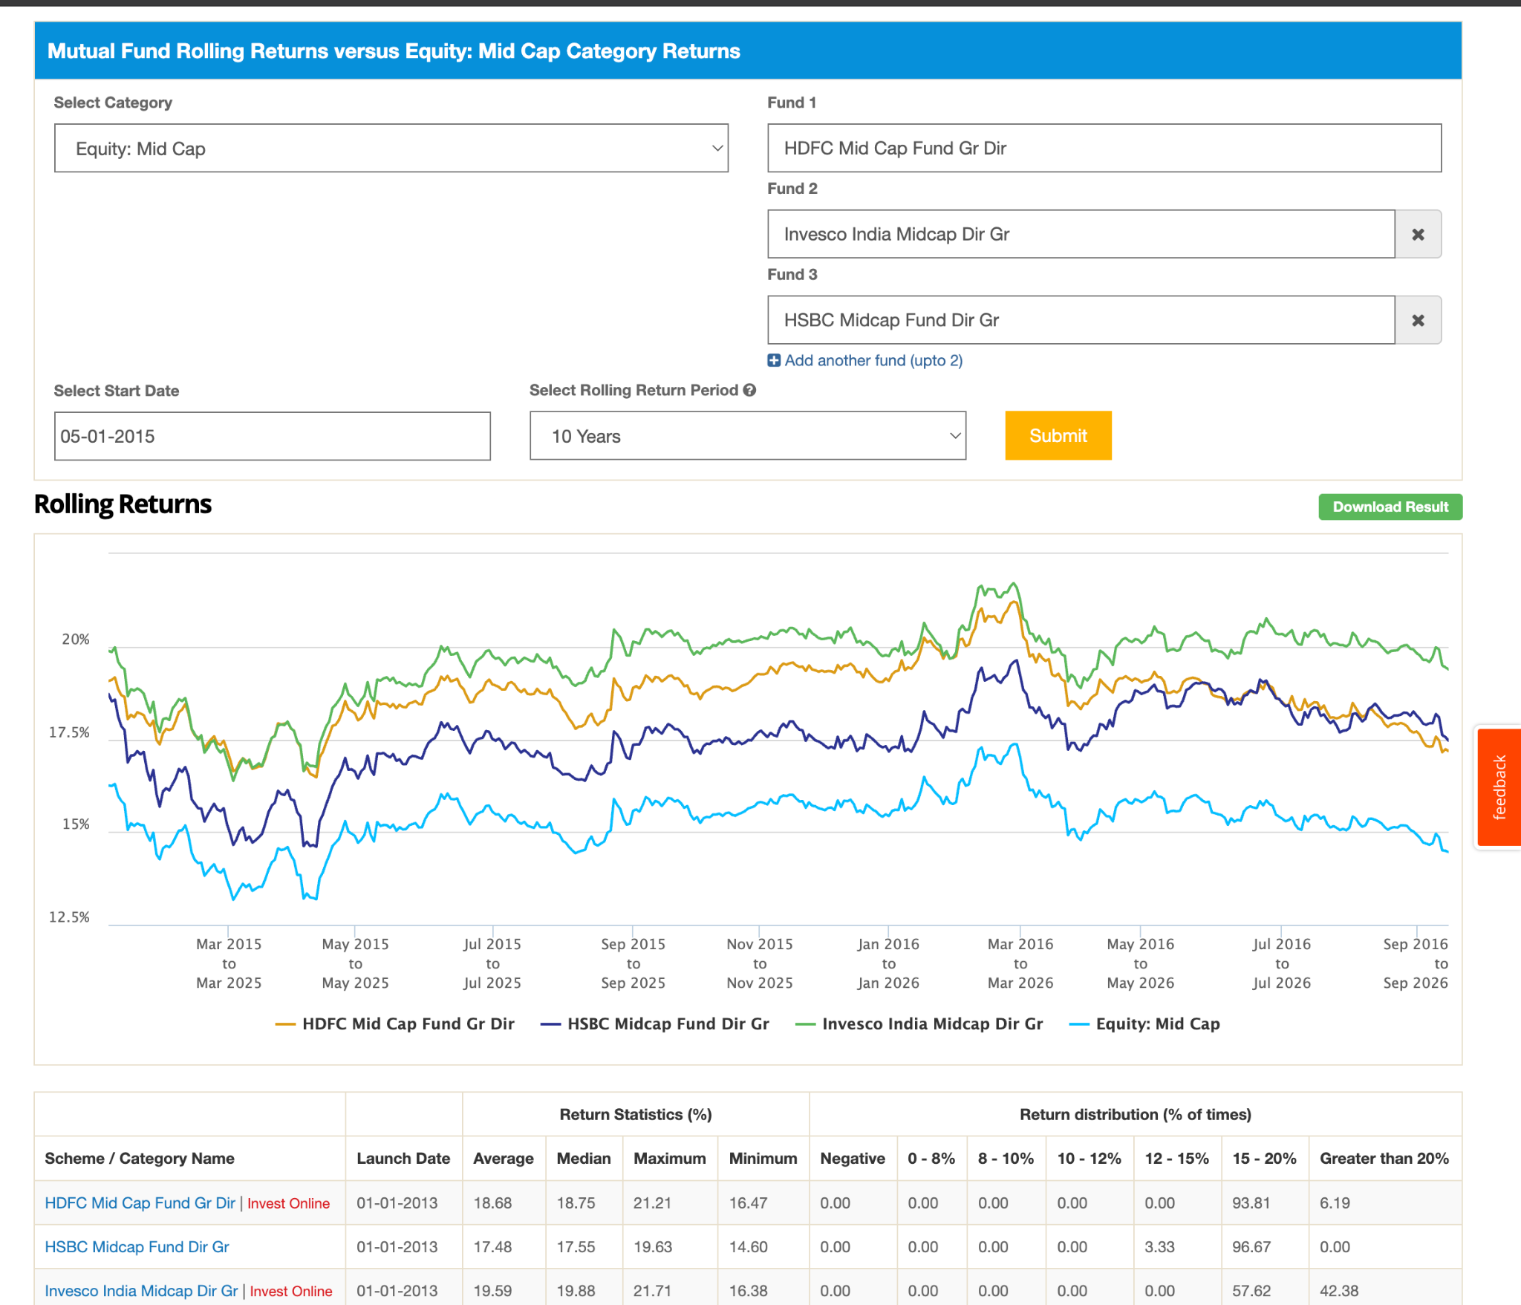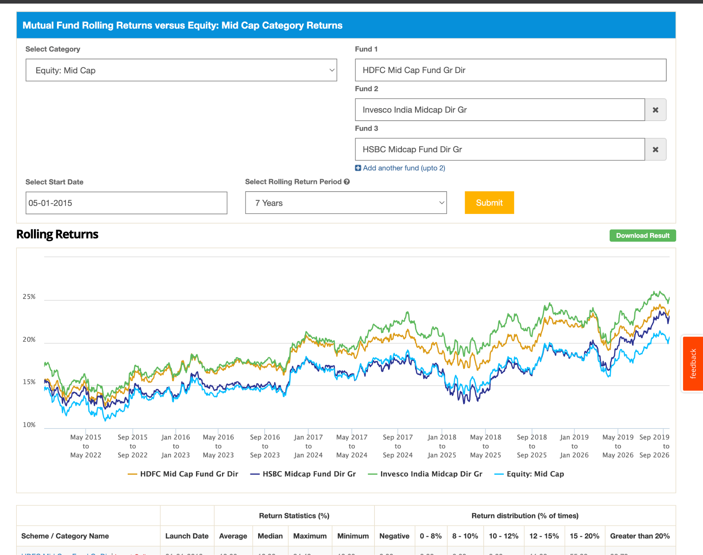
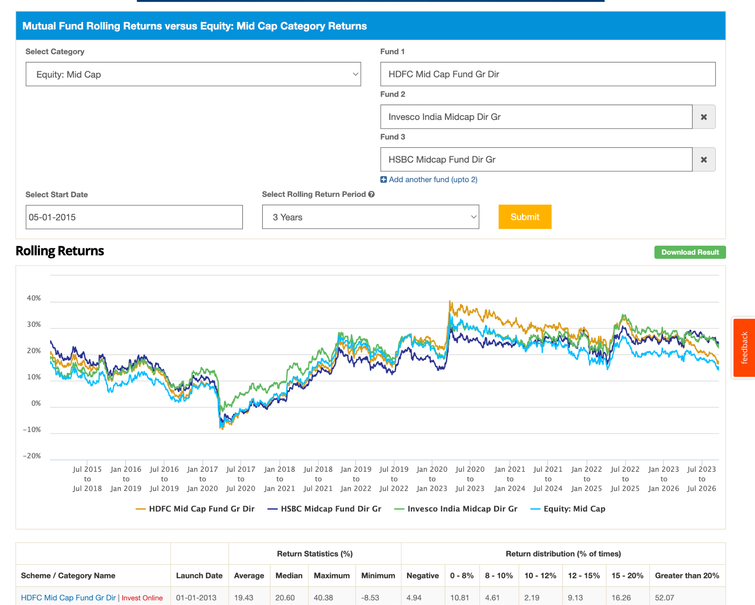

5. axis ( ignore, as i compare with othe rits consistency relatively less other other liek hdfc , invesco less SS )
6. whiteoak ( ignore, seems good return but ignore for now coz amc is small 40k crore, too much leadership role issue. 24th rank by aum, but definitely in bookmark. )
11. dsp ( ignore , have better fund manager and this consistently less then other, people also added less money in this as compare to other. ) 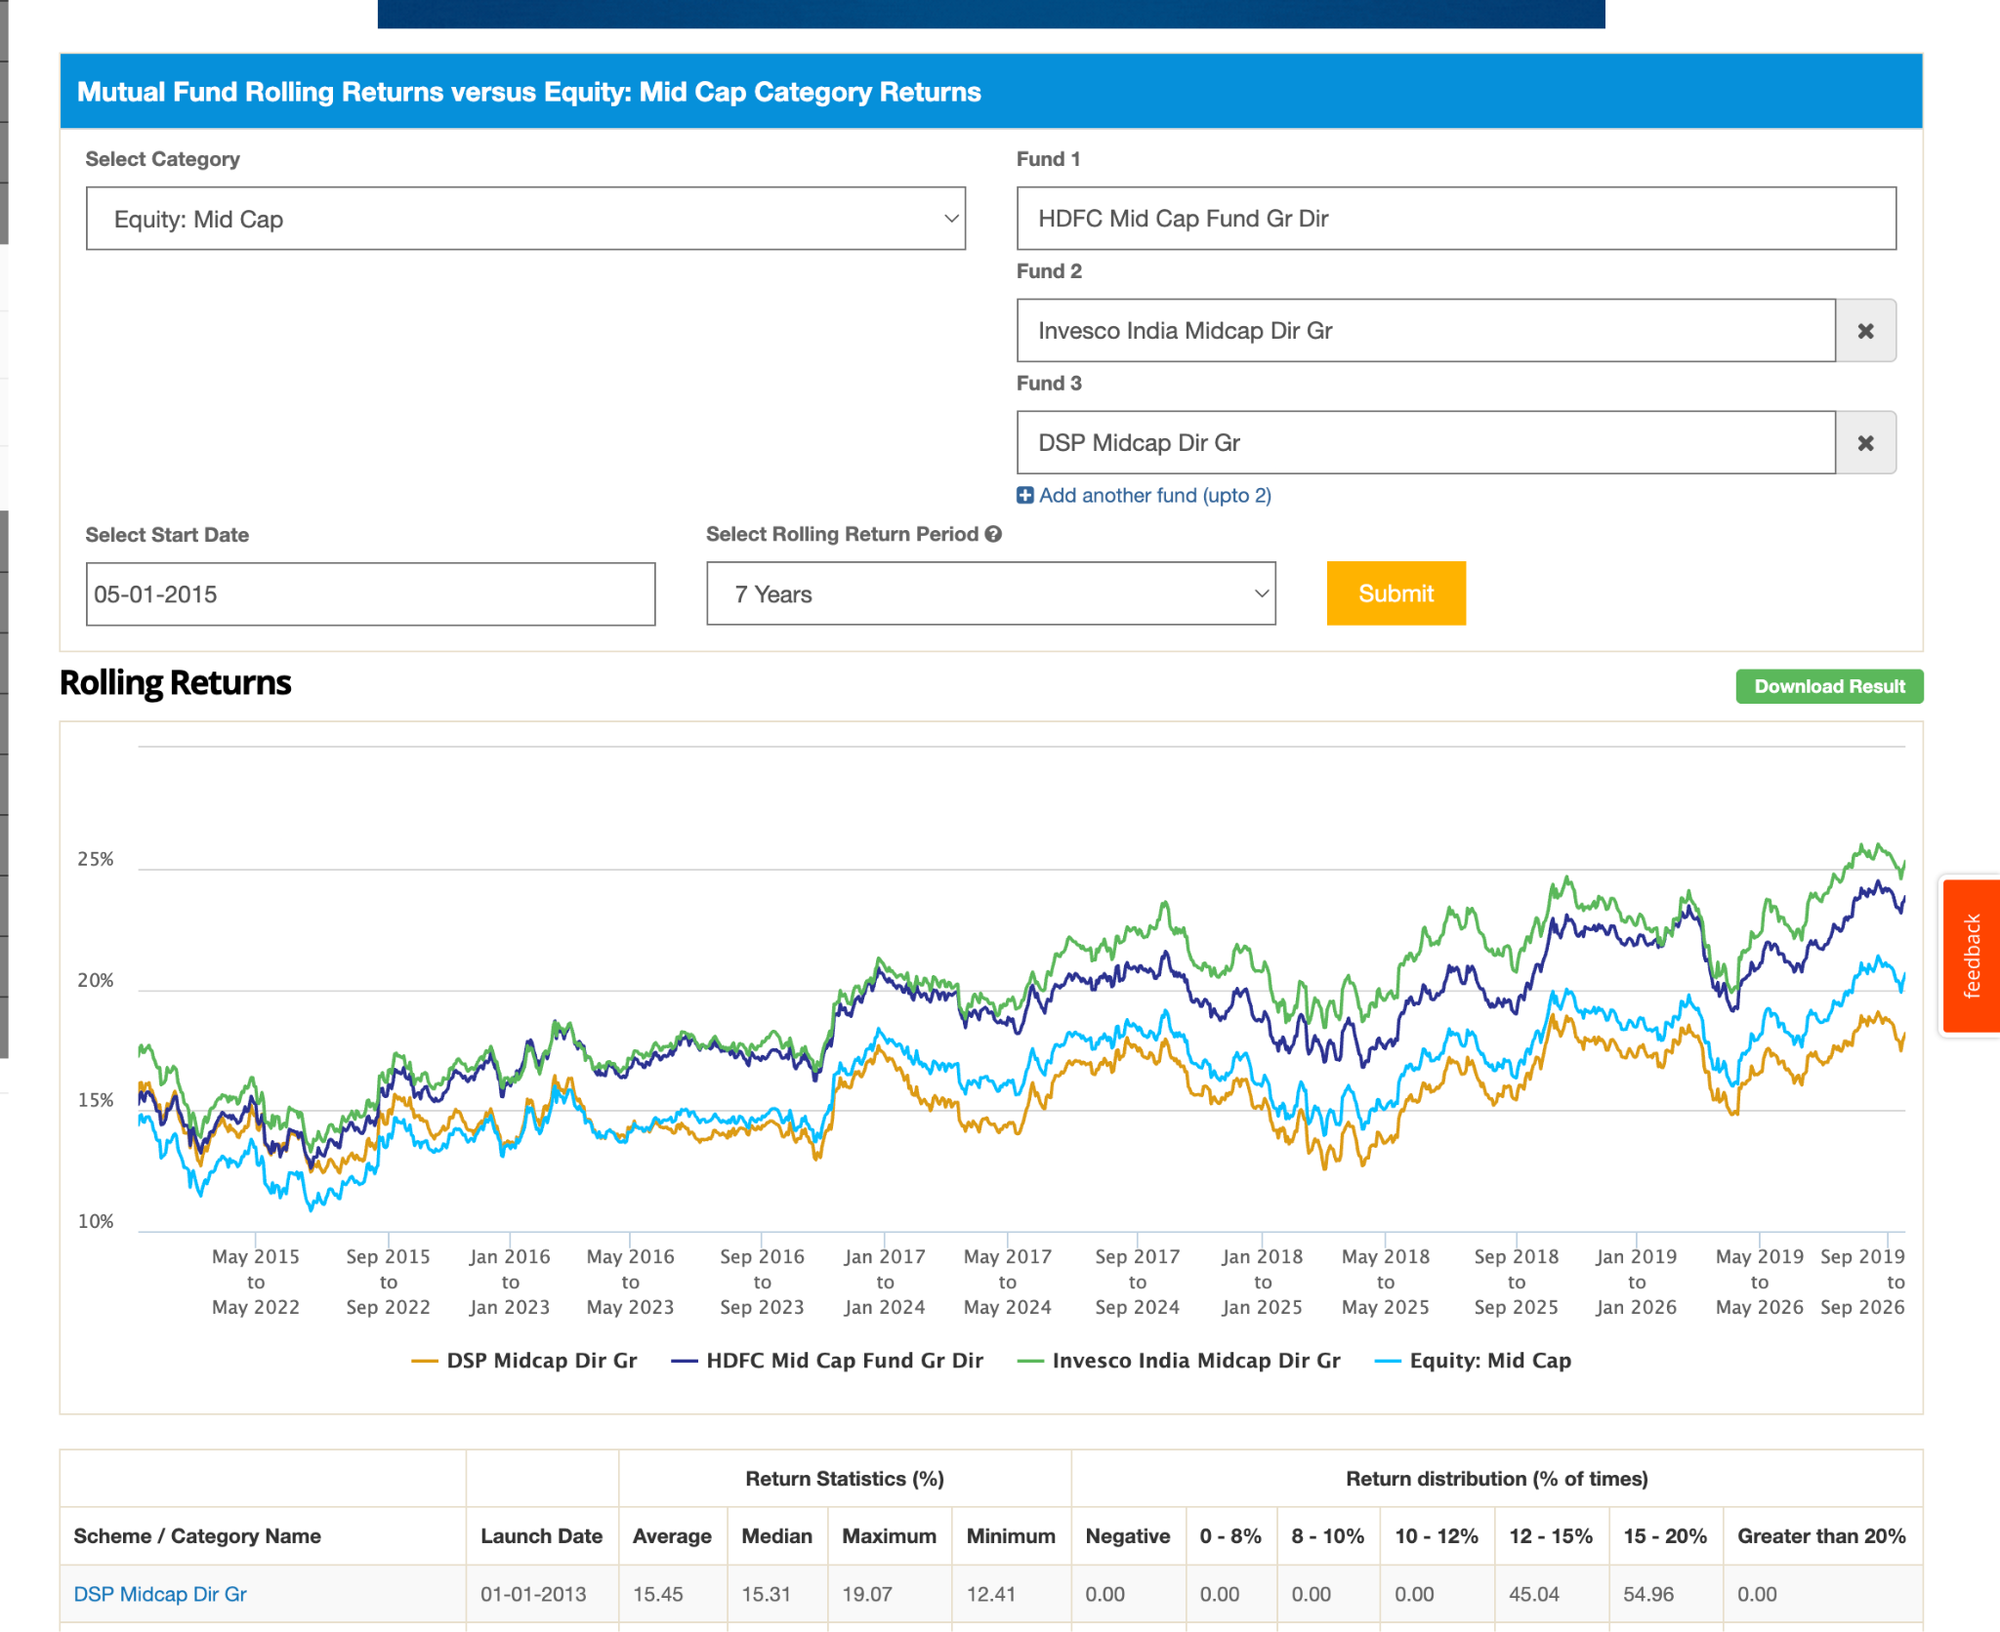

so for now chosing let say hdfc, invesco, edeil. what if have to chosse two ? ( hdfc has great fund manager team for now, perfomance -> edeil, expense ratio -> edeil, aum -> edeil no large aum, 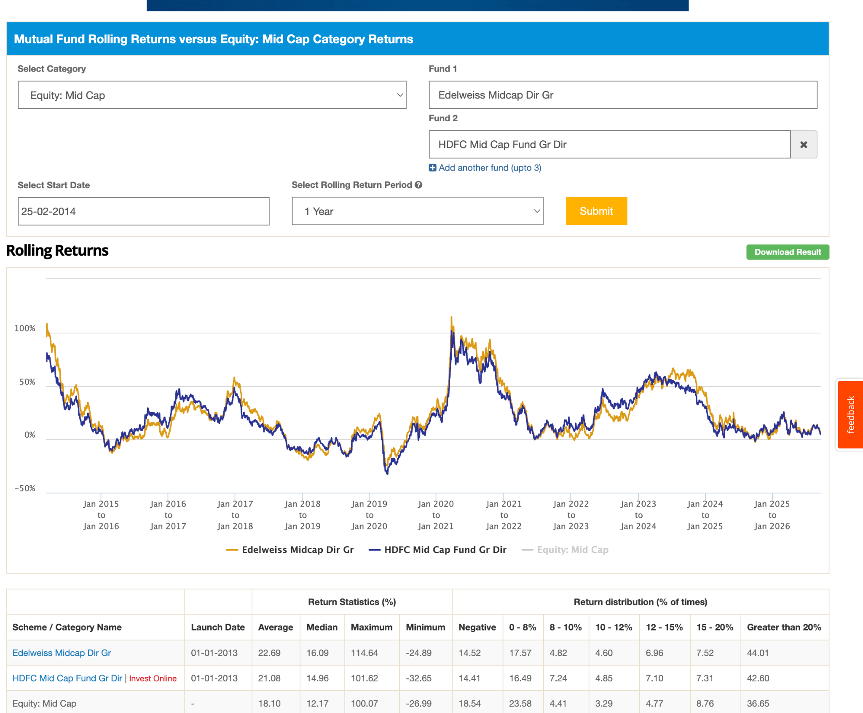 )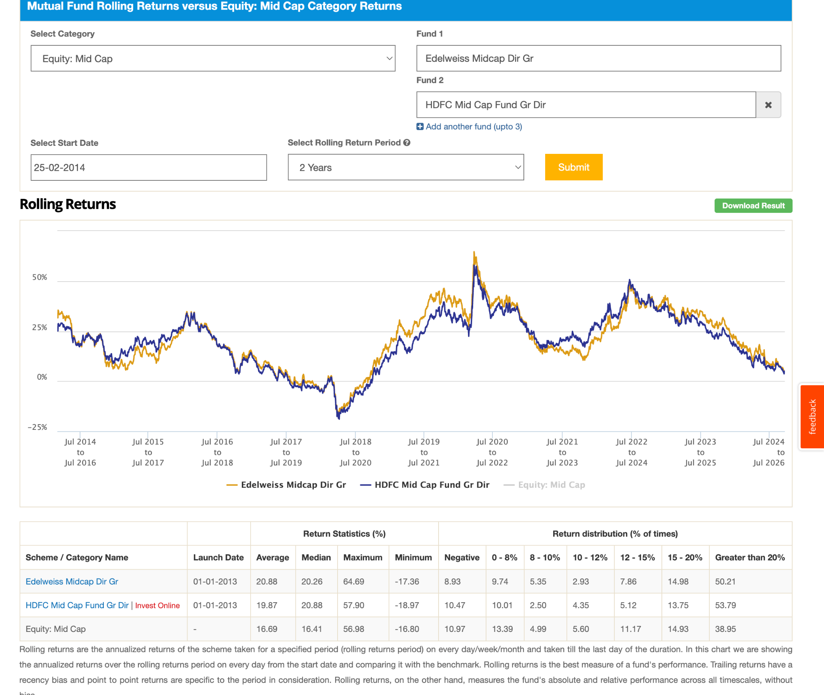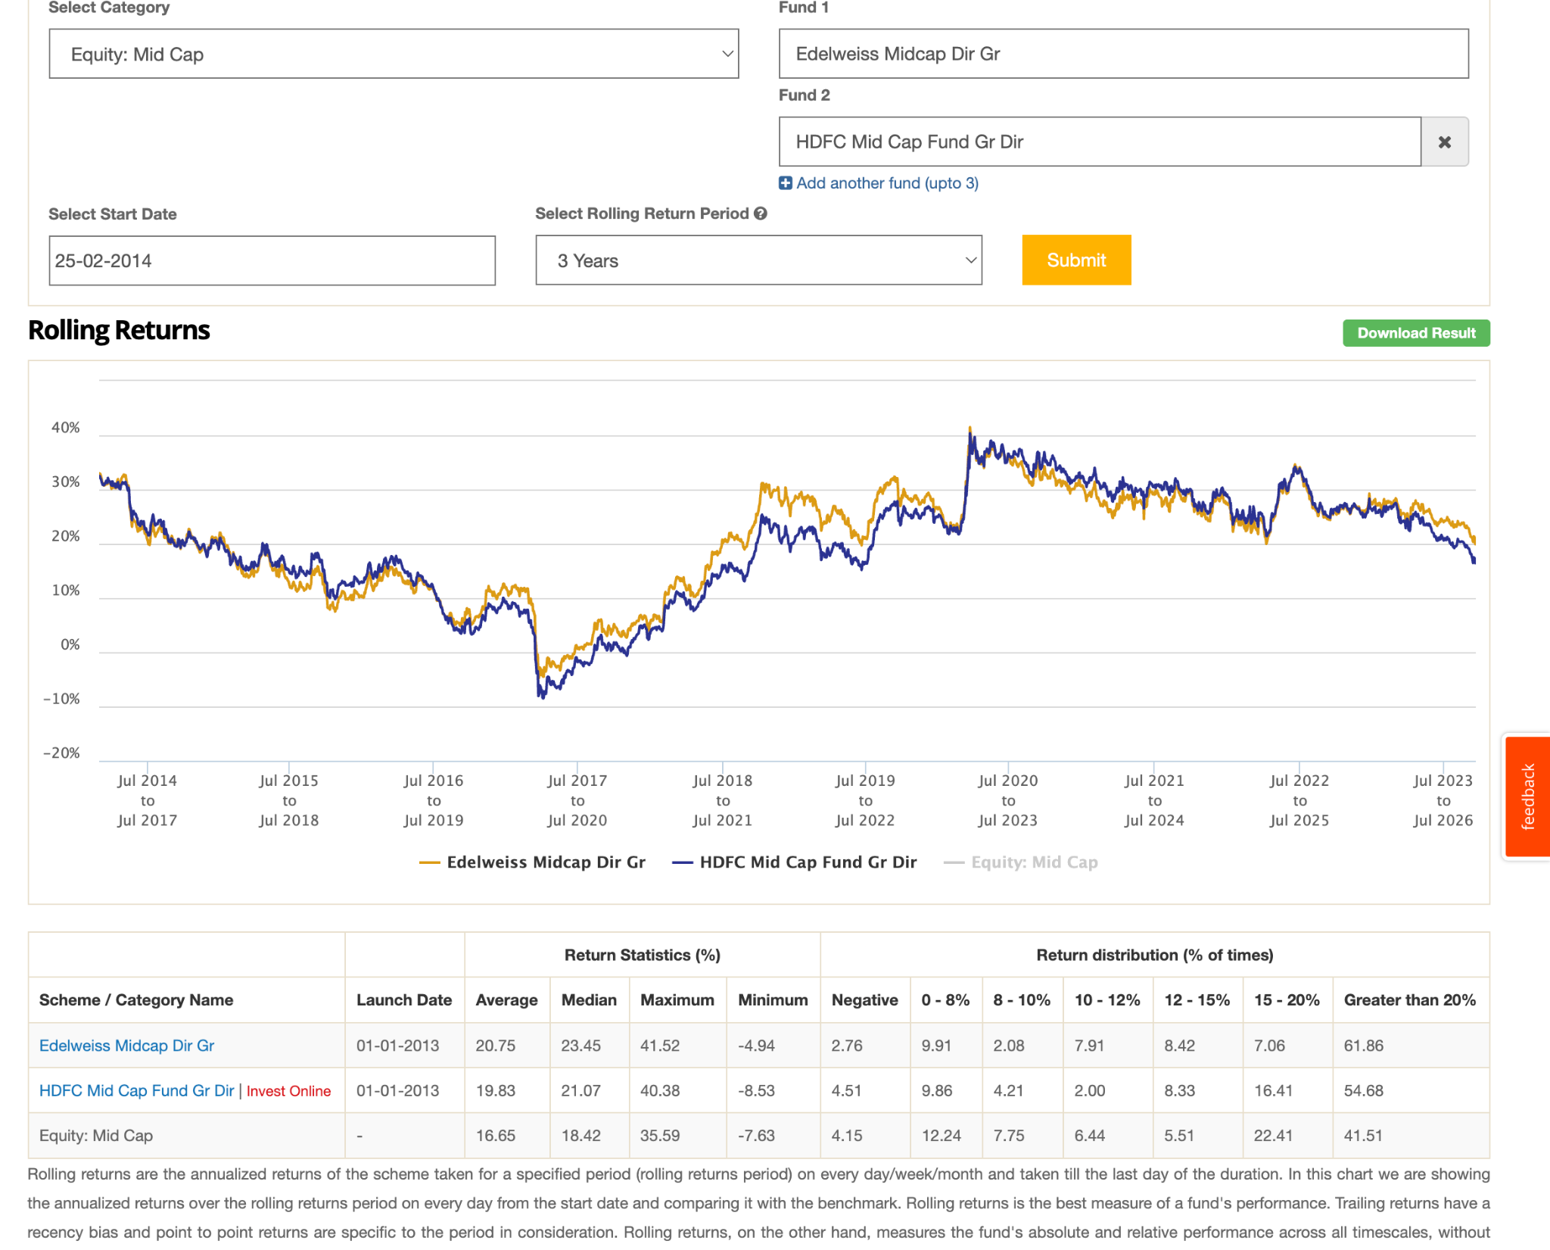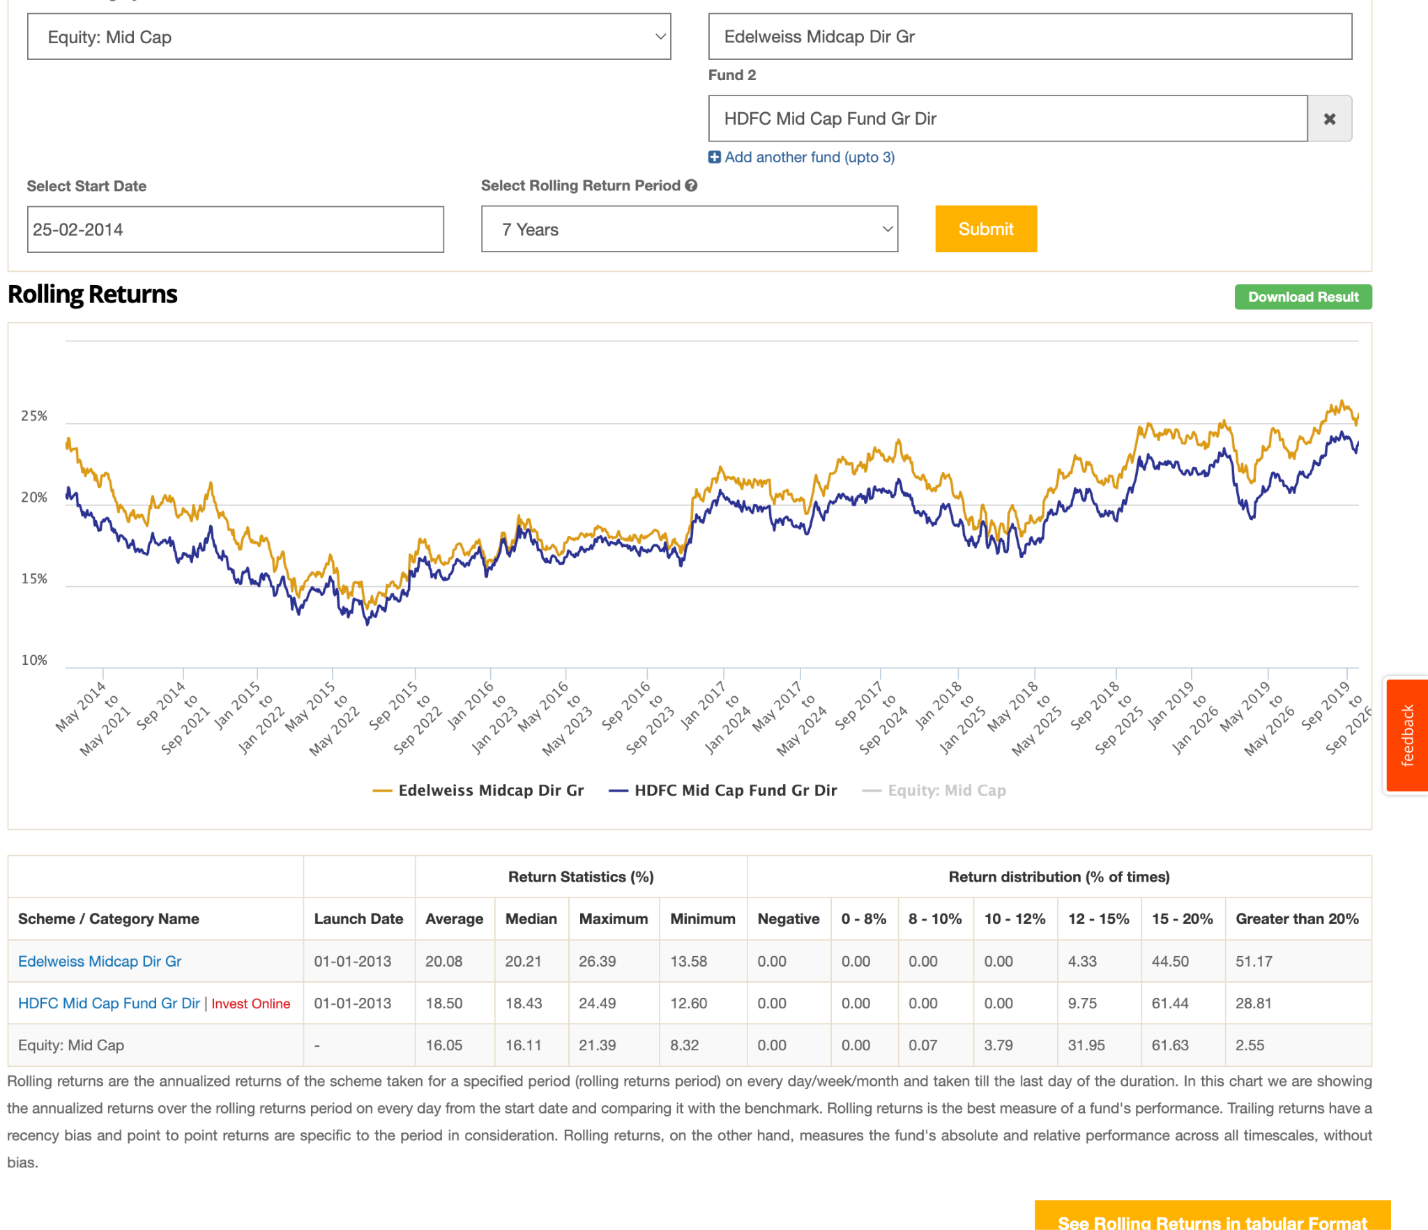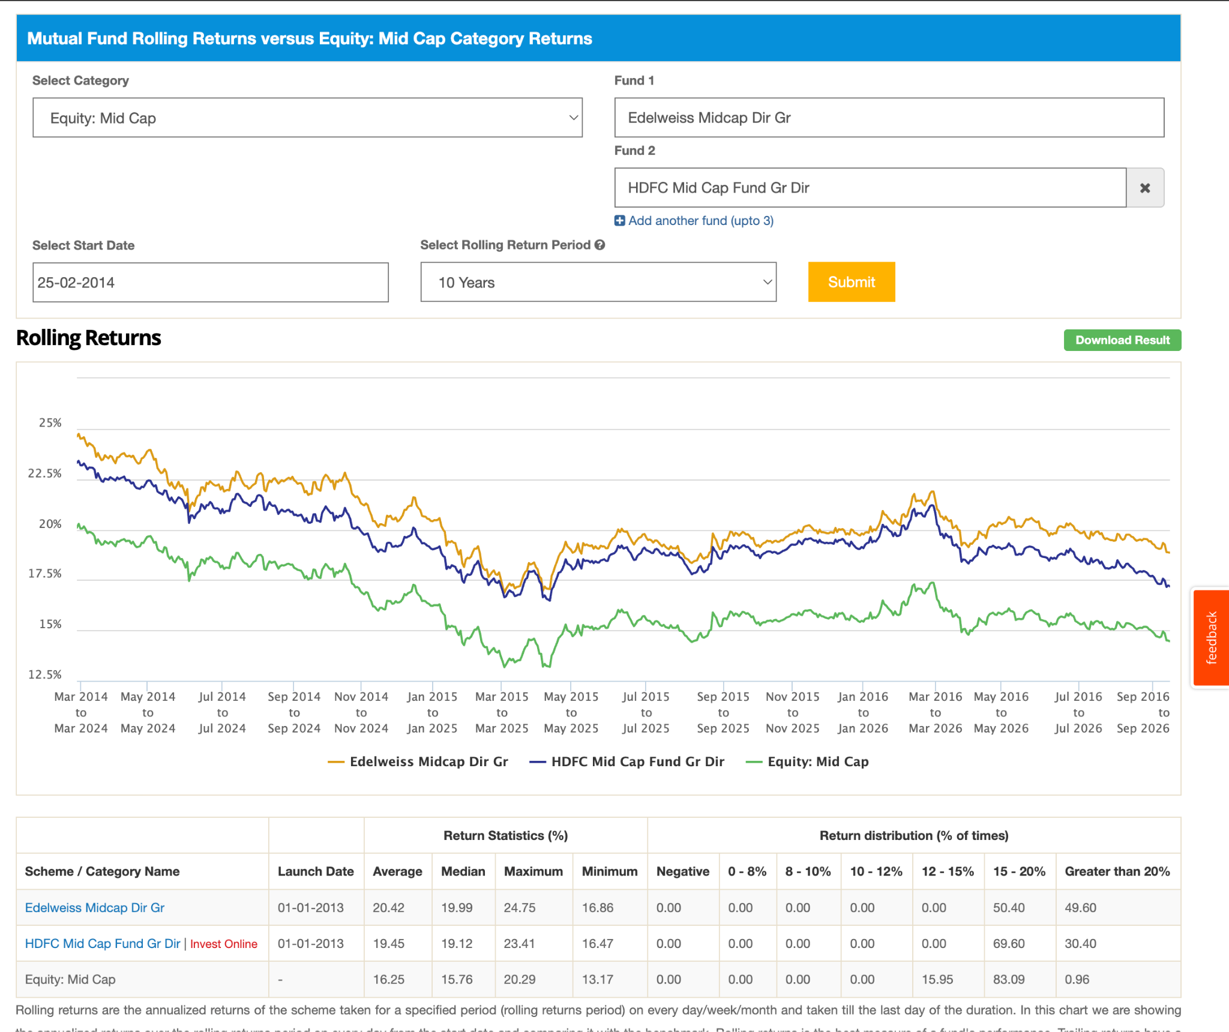

Passive:
- Pros:
- range is fixed.
- no active monitoring.
- no fund manager bias, mental peace.
- just put and no see.
- Cons:
- it's a formula, based. not intelligence or strategy.
- 100% mid cap, might work badly in downfall as compare to activ
- only one index fund which is only 5 year old , no major bear
market, no idea how the index fund will perform.
- no alpha general at all.
- last 5 year performing well , relatively hard to beat for activ mid
cap. 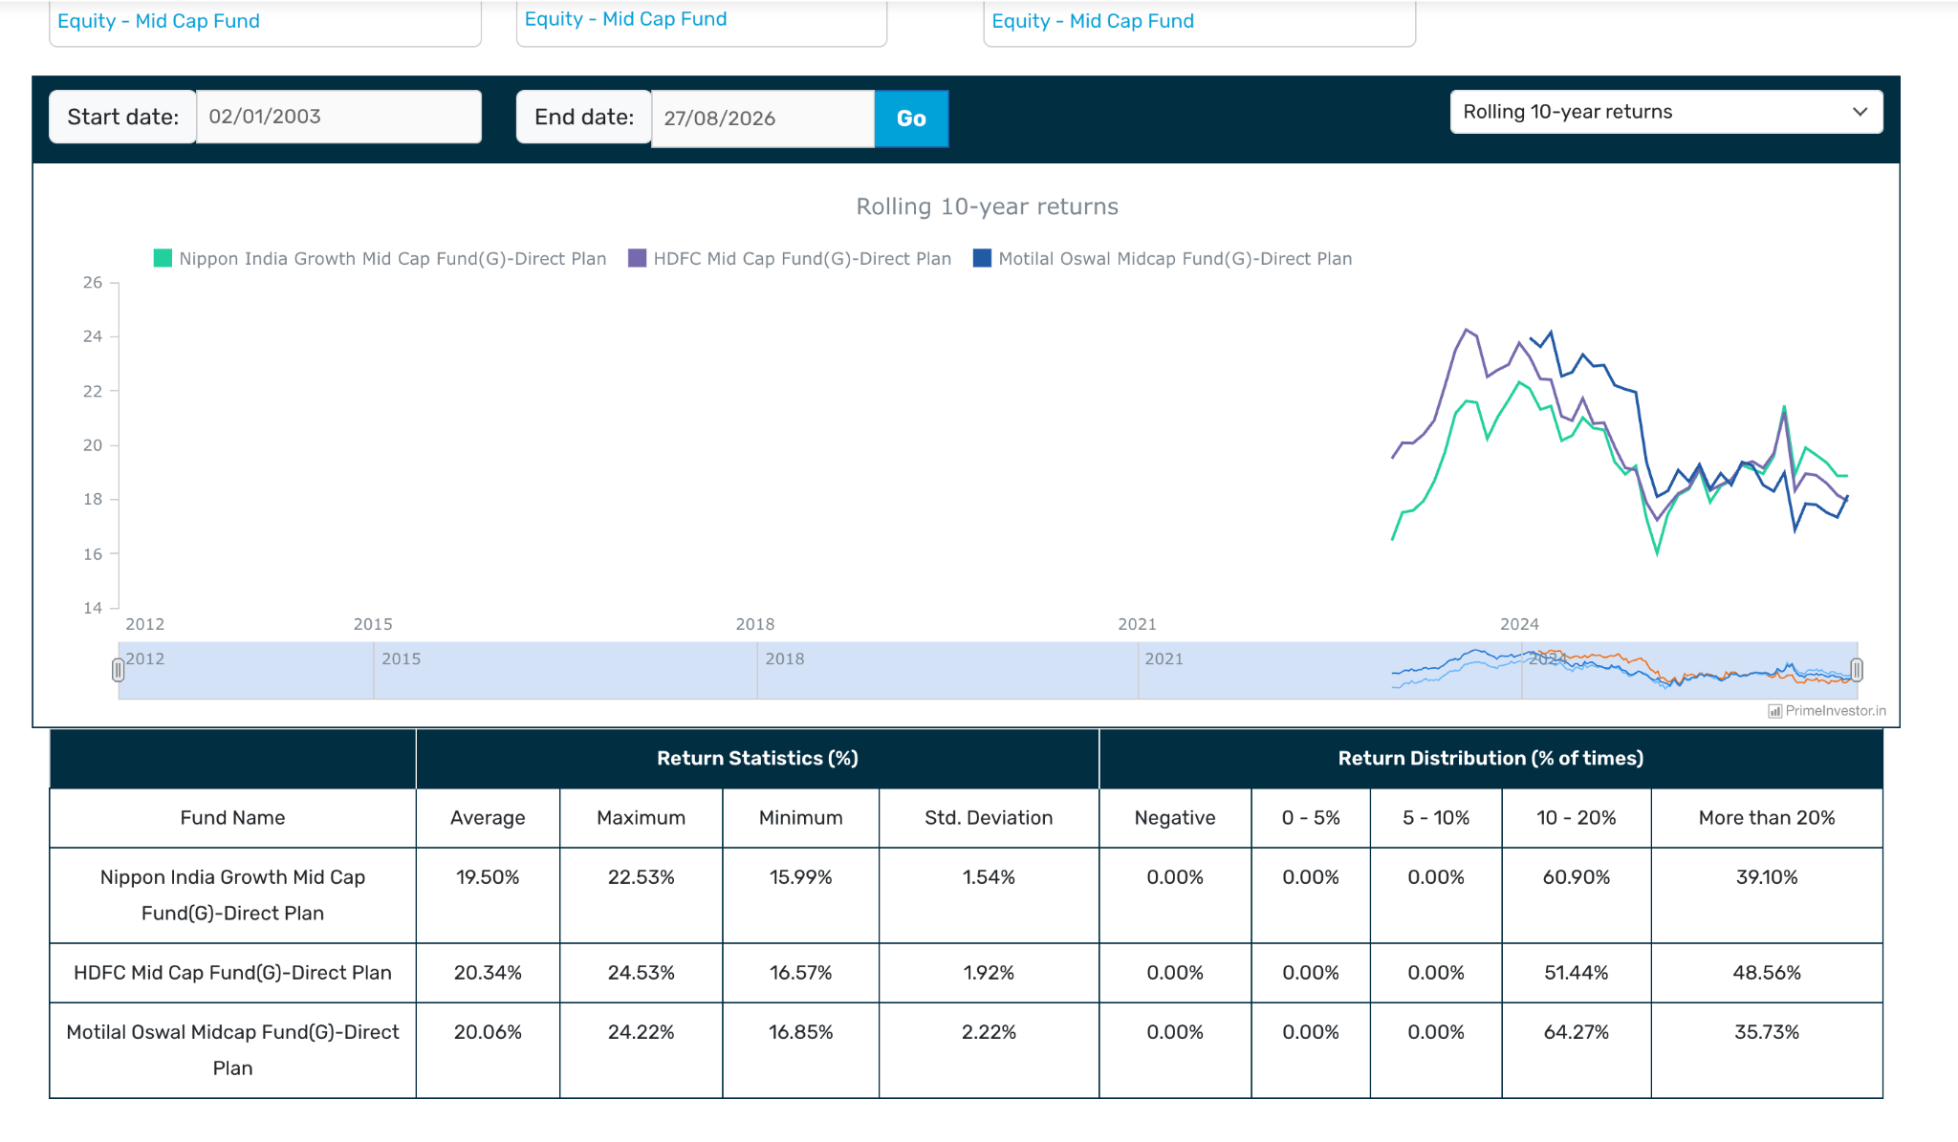
- 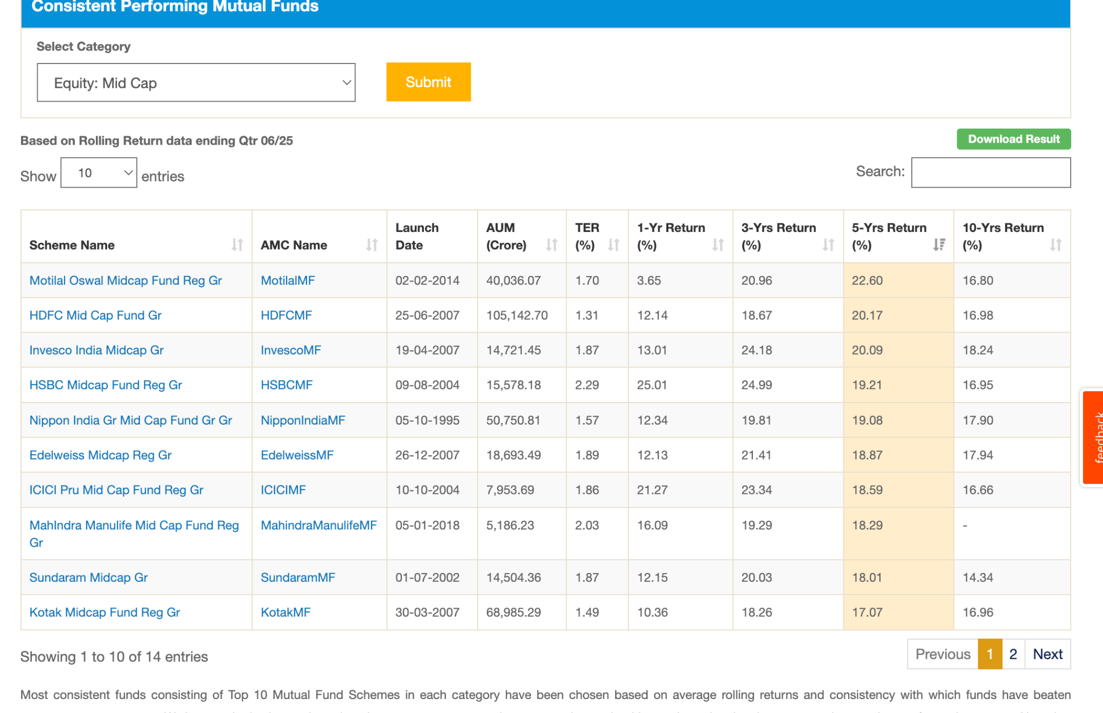 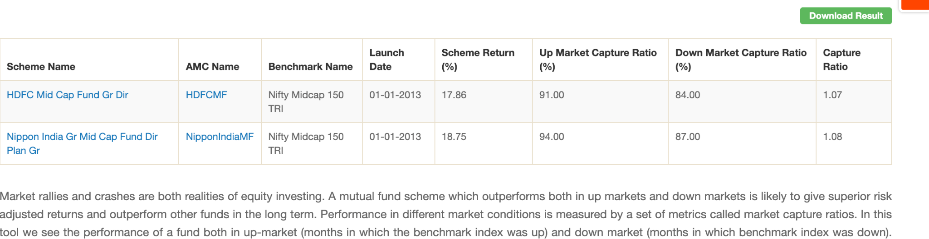
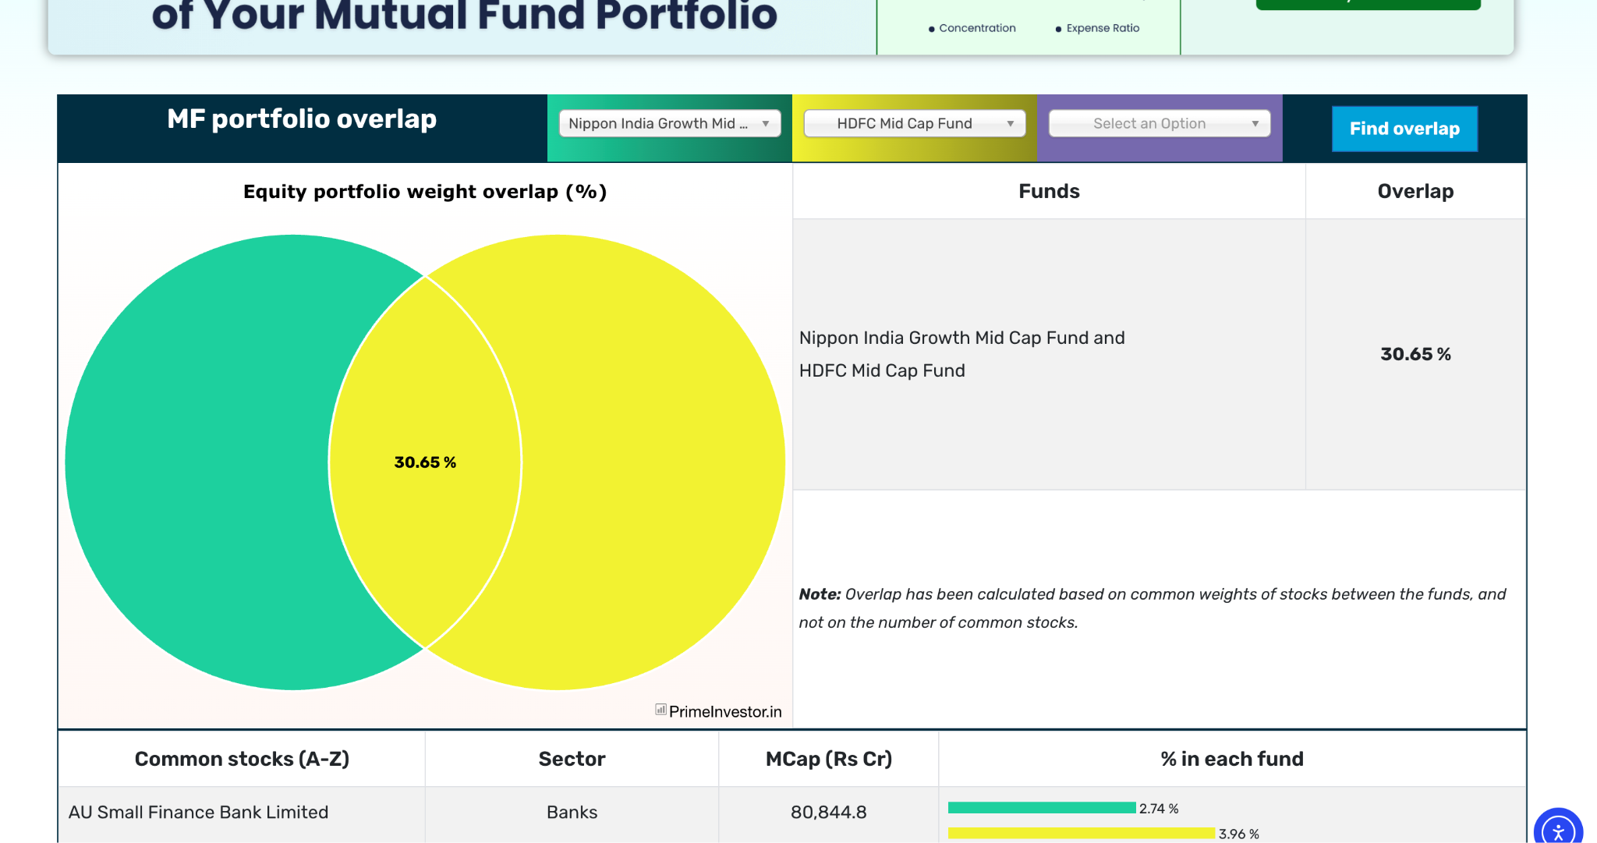
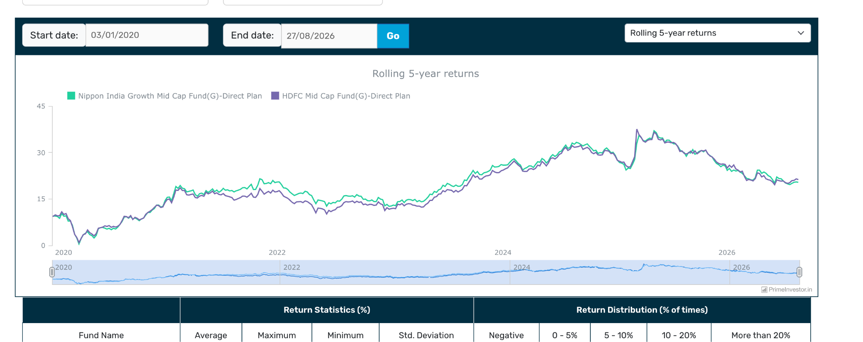
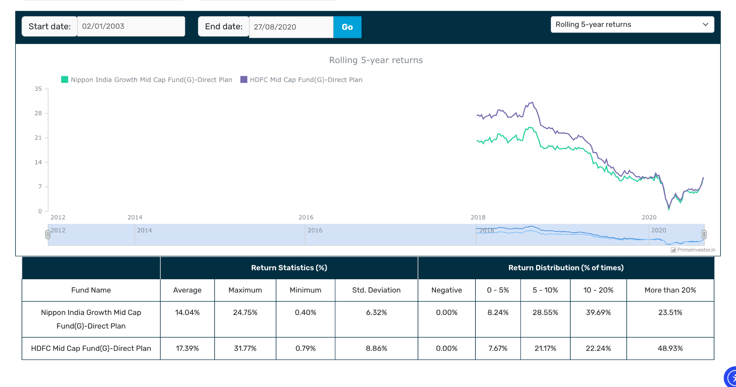
- small cap ( 2-3 small cap ) :
-nippon,bandhan -> first invest in this. then learn etc and see invesco and other also. as per research , active funds prefer ( but take 2-3 of different style non overlapping ), reason small cap is universe a formula might not perform better and mostly funds are able to beat , small cap is very volatile formula can be in down, high tracking error due to high turn over, down side protection. for now chossing good few active funds or ignore small cap directly do it via flex/multi etc type.
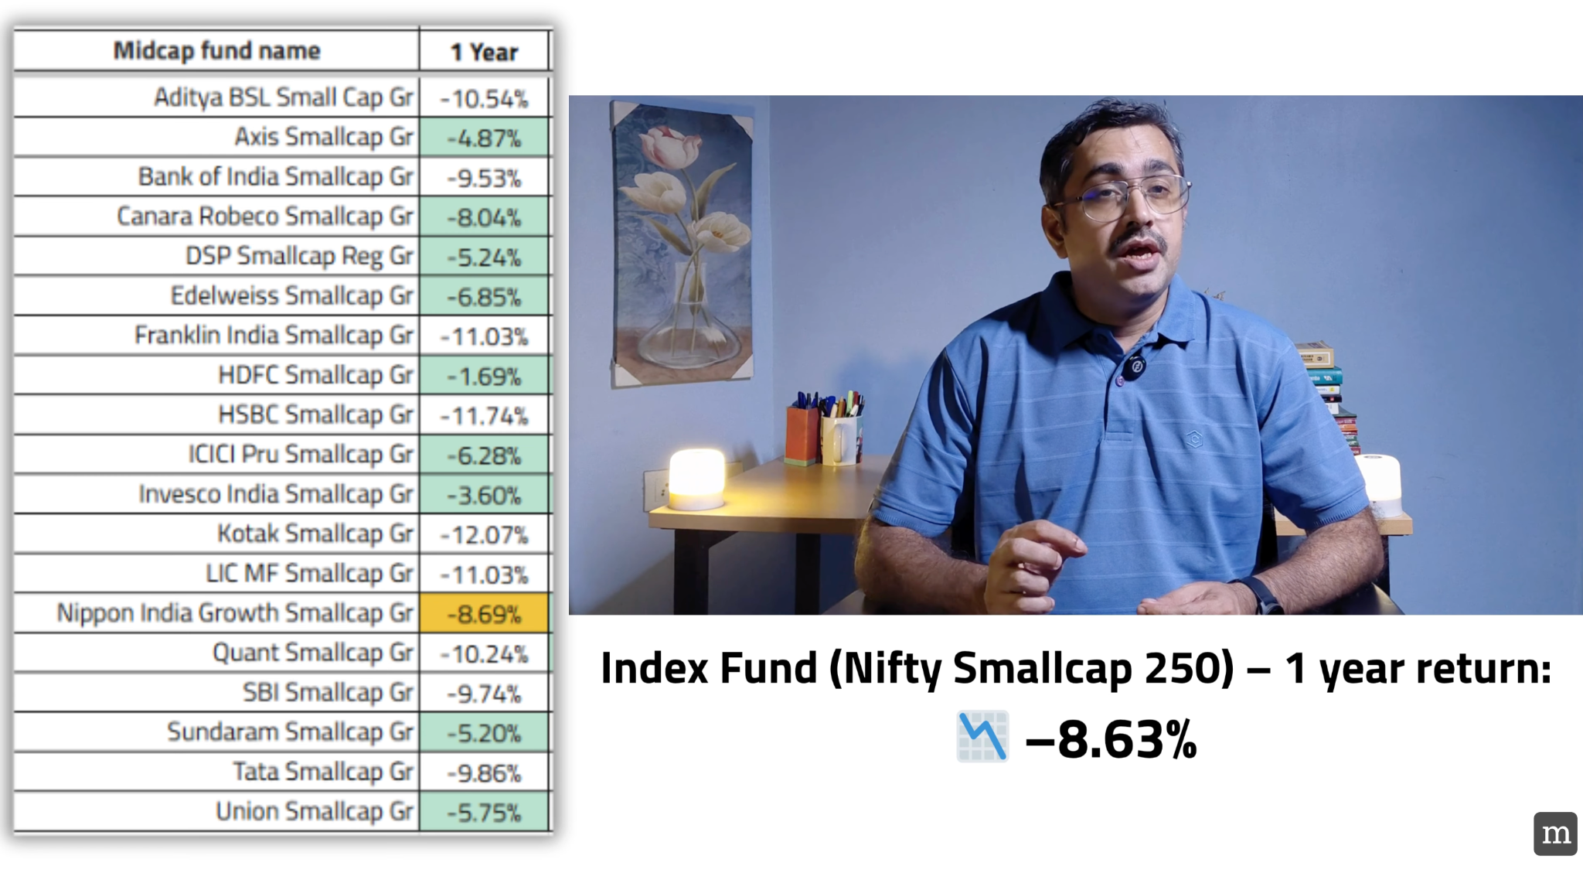
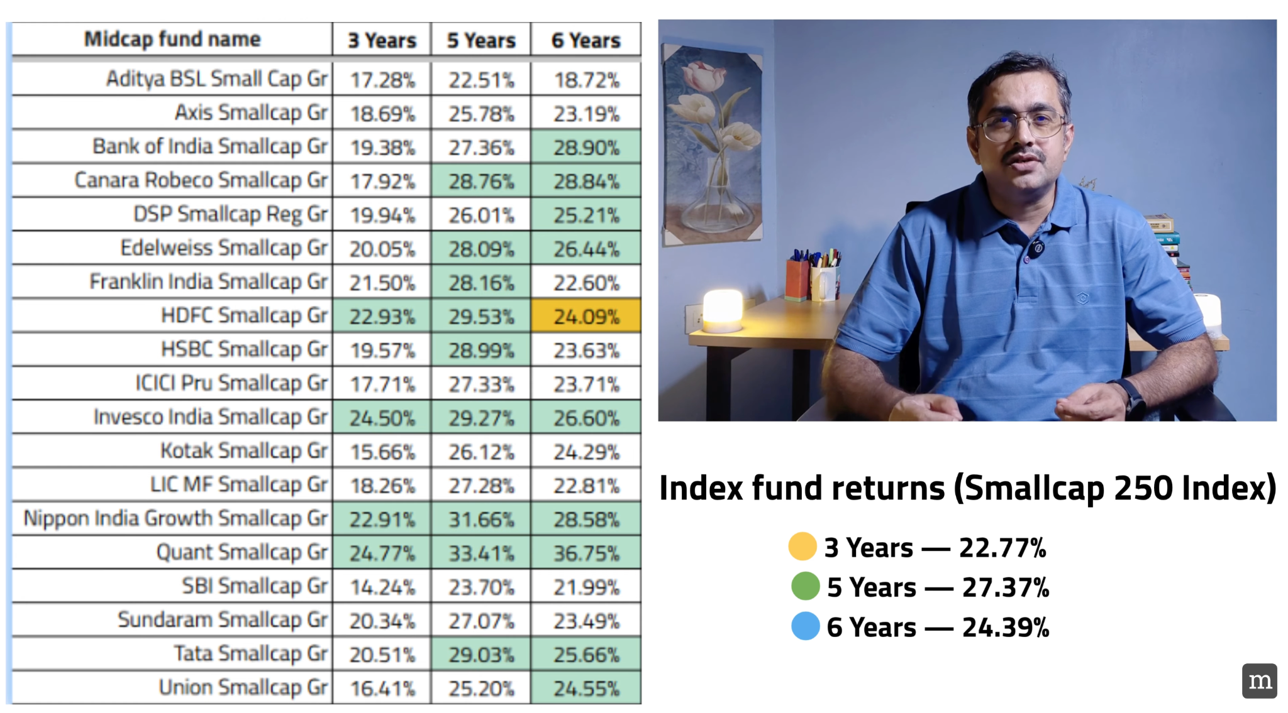

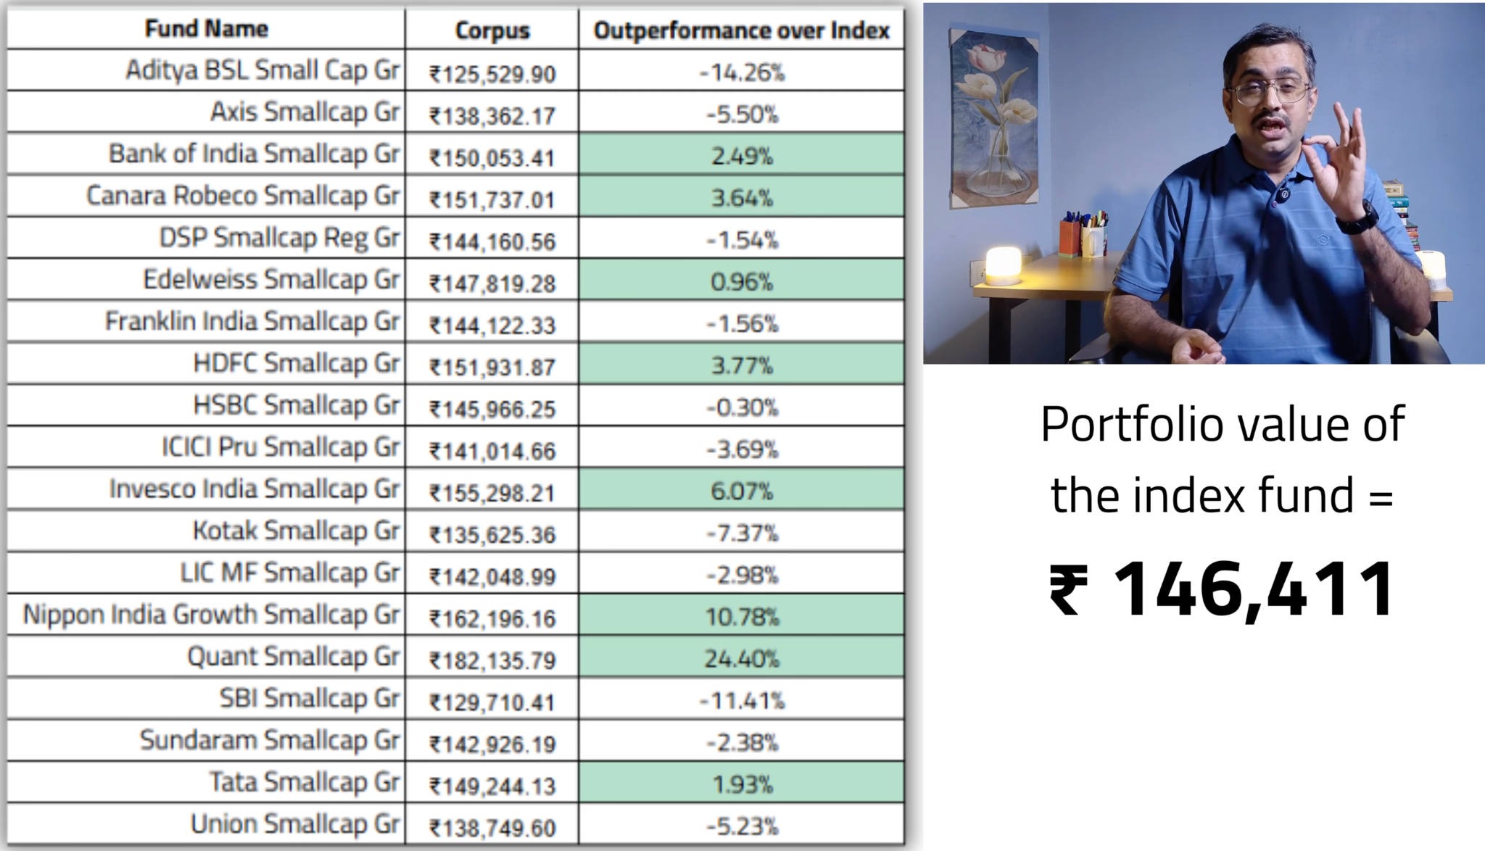
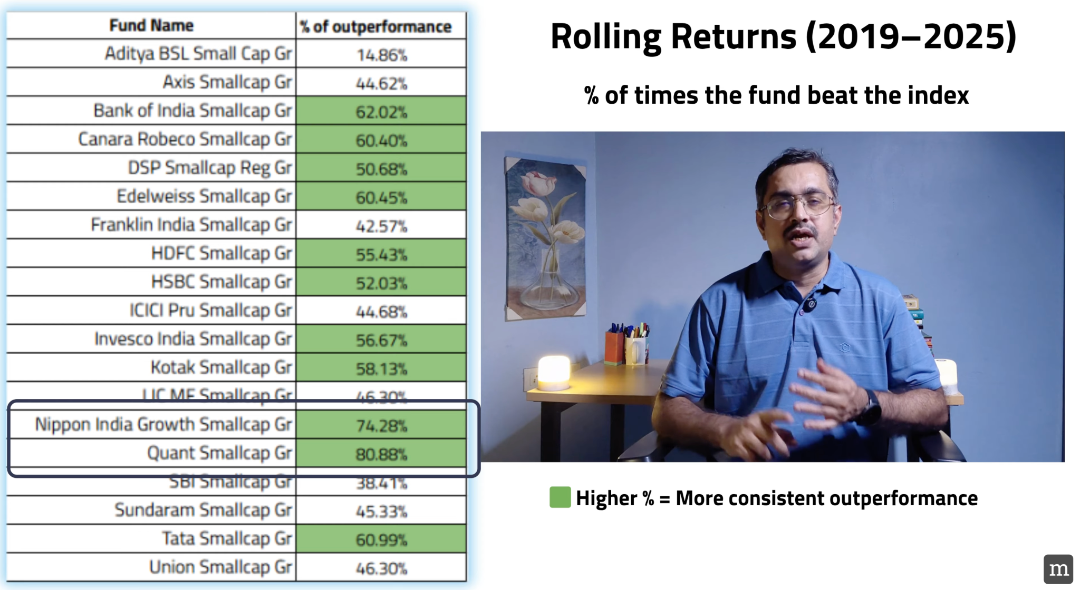
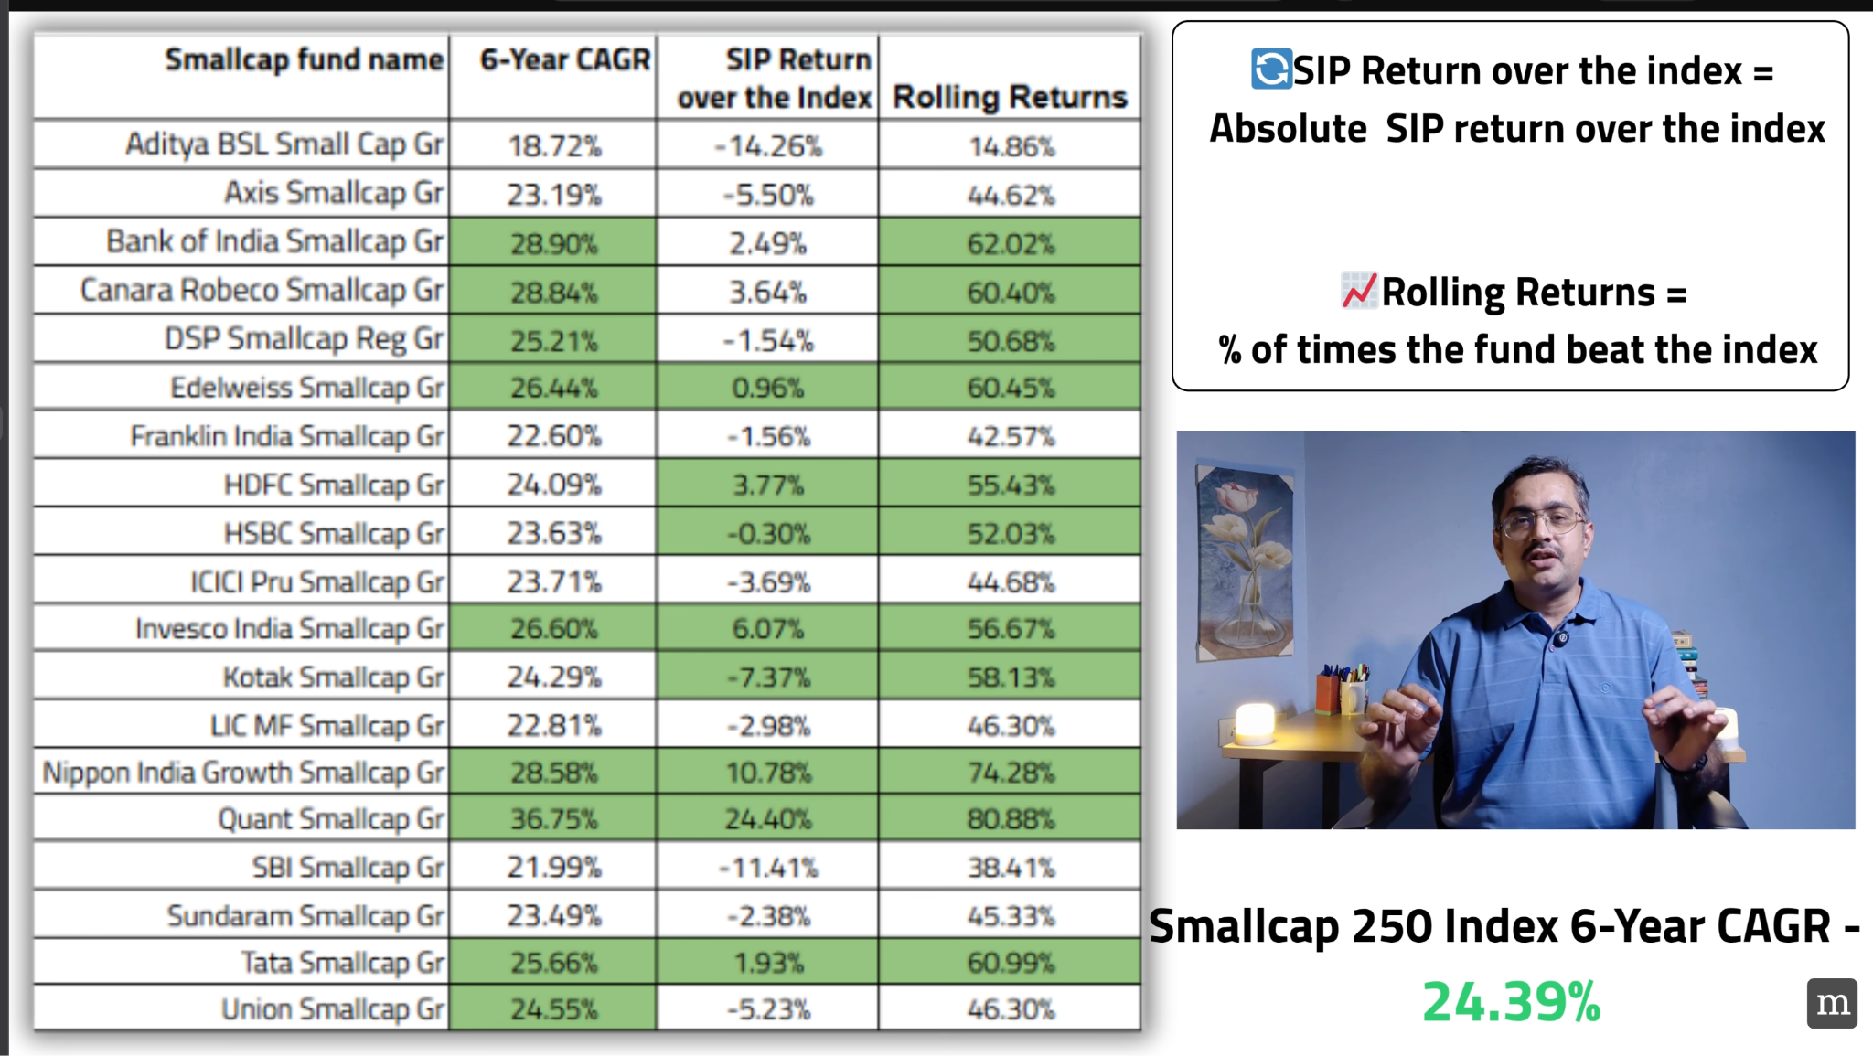
Is the portfolio too aggressive ?

For e.g.

50 -> invest:

20-25 => PPFCF => 1.5 monthly -> 1 saal -> if you get an opportunity in bulk.

